Praying Mantis
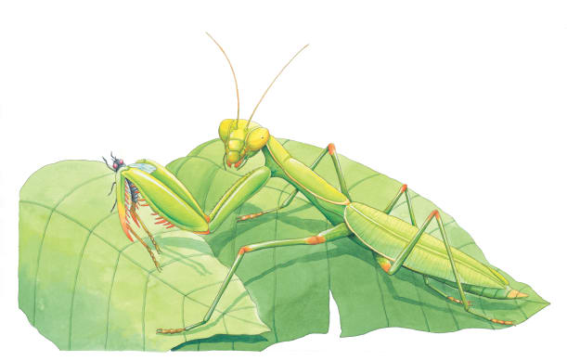 | A praying mantis is a fierce ____________. A praying mantis sits perfectly still with its legs folded, waiting for an __________ to pass. They, in a flash, it reaches out and grabs its ________.
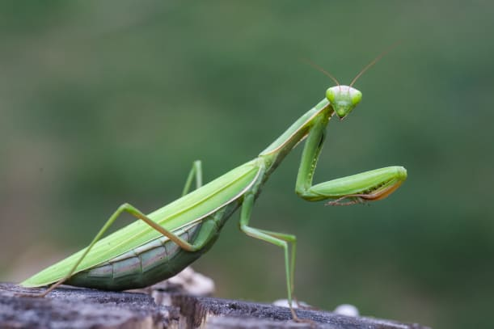 | A mantis uses its long front legs to grab __________, like flies. Rows of sharp _________ on each leg make it hard for its prey to escape. A praying mantis can turn its __________ almost all the way around as it looks for food!
 | Praying mantises can __________ into leaves and other plants. Other types of mantises, like the orchid mantis, blend into beautiful flowers. This helps them surprise their _________.
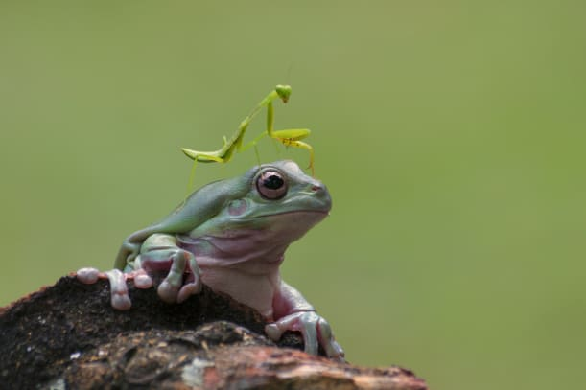 | Sometimes a mantis will attack creatures larger than itself, such as _________, or mice, or even small birds!

