Pets’ Homes
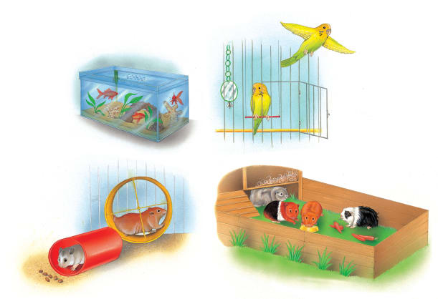 | It can be great fun looking after a _______. There are lots of different kinds to choose from. Wild animals take care of themselves, but pets need people to give them food, water, and a clean, safe _________.
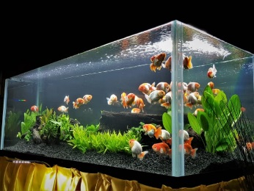 | Goldfish dart around and nibble on plants in a _________ of fresh water.
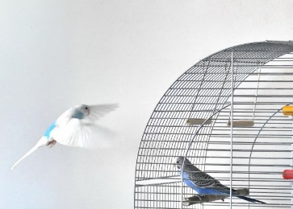 | A parakeet flies out of its _________ to exercise.
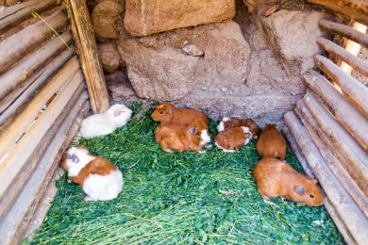 | In warm weather, guinea pigs scamper in an outdoor ________.
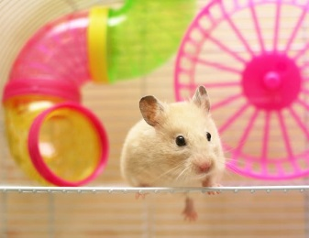 | A pet hamster’s home is like a playground with an exercise __________ and more!
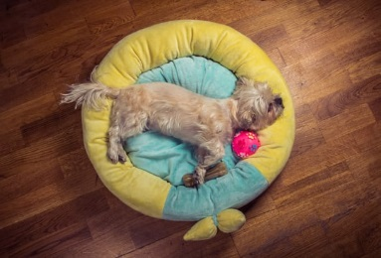 | A soft _______ is a perfect place for a dog to sleep and hide toys and bones!

