Octopus
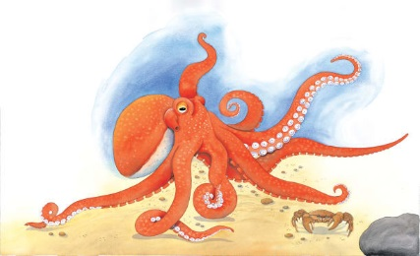 | A slippery octopus spends the day asleep among ________ at the bottom of the sea. At night, it slither out of its rocky _______ to look for tasty food to eat. Most of the time, an octopus crawls across the sea floor, but it’s also an excellent swimmer.
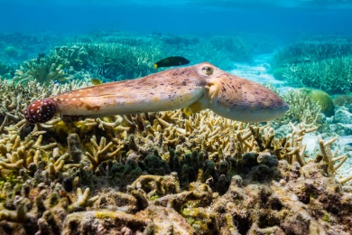 | To swim, an octopus stretches its ________ into a long, thin shape and shoots backwards through the water.
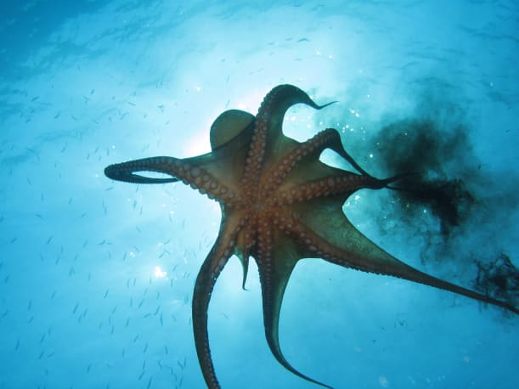 | An octopus escapes from danger by squirting dark-coloured _______. The ink hides the octopus while it slips away.
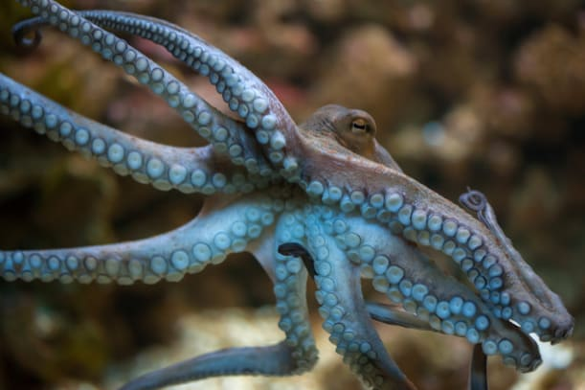 | An octopus has eight wiggly arms called _______________. Rows of strong _____________ on the tentacles help an octopus grip rocks.
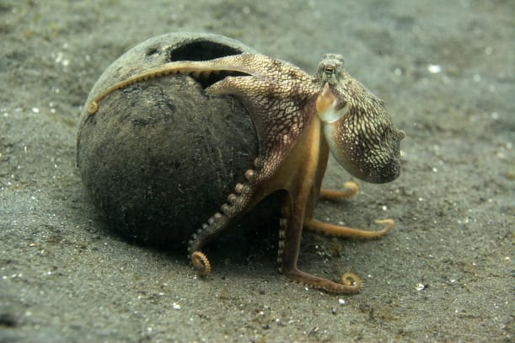 | An octopus has a soft ________. This soft body makes it easy for it to squeeze into tight spaces.

