Maiasaura
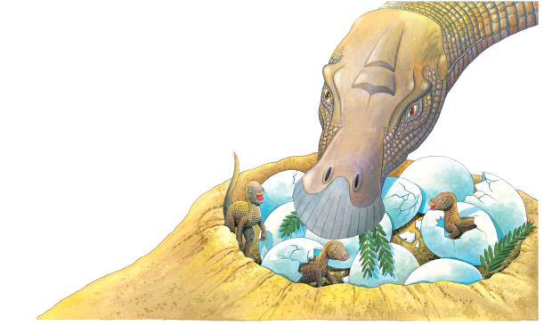 | Maiasaura had a flattened beaklike _________. Its name means “good mother lizard.” Maiasaura laid ________ in a nest, as most other dinosaurs did. But unlike some dinosaurs that left their eggs along to _________, Maiasaura guarded its eggs and fed its babies.
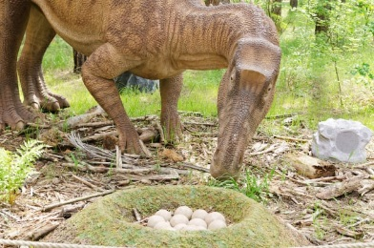 | A mother Maiasaura dug a cozy ______ in the ground to lay her eggs. There were as many as _____ large eggs in a nest.
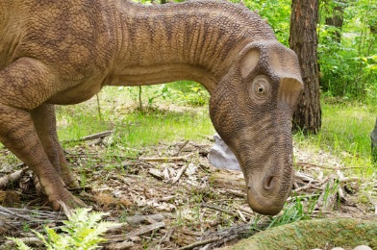 | Maiasaura had a flattened _______ like a duck’s bill. It also had powerful ________ with hundreds of teeth. It ate ________ growing low to the ground.
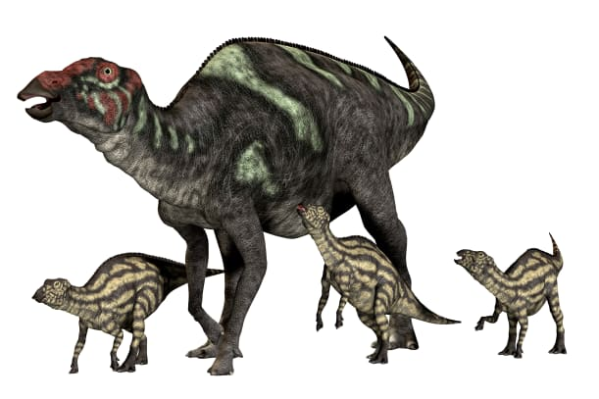 | Maiasaura lived in large __________. These herds could have thousands of dinosaurs.
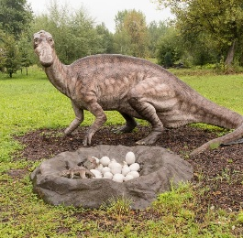 | This baby just __________. It looks like it’s mother, only smaller!

