Logs and Leaves
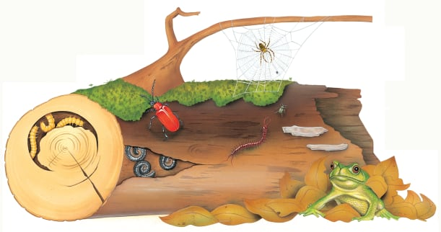 | All kinds of tiny creatures make their homes on a mossy log. Here, they can sleep, eat, hunt and lay their _______. When the log becomes too crowded, the pile of ____________ next door makes a safe place to shelter, too!
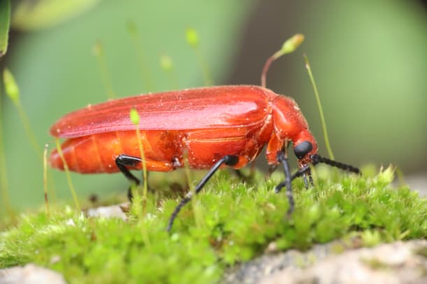 | A shiny beetle crawls over the ________. It is looking for a crack where it can lay its eggs.
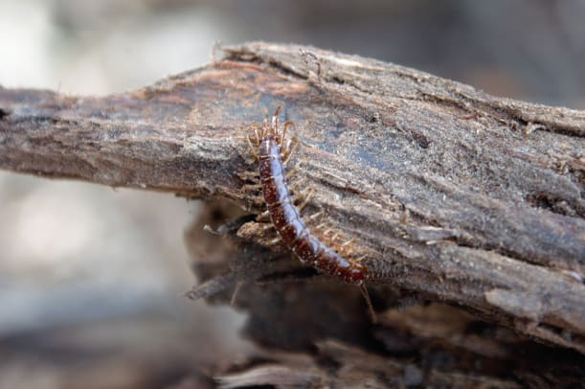 | A centipede is a fierce ______________. It hunts for spiders and beetles on a log.
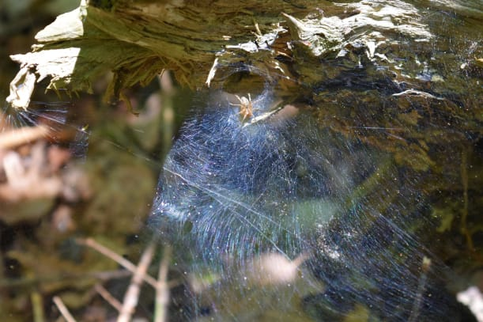 | A spider find plenty to eat on a log. It spins a _______ to catch a juicy insect.
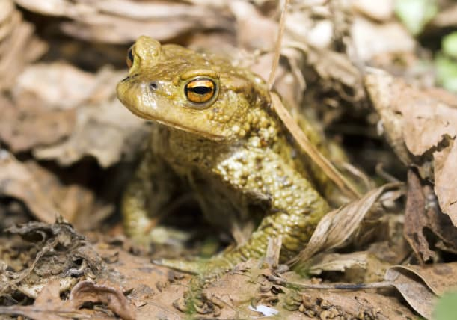 | A toad is cool and safe under a mound of fallen ______________.
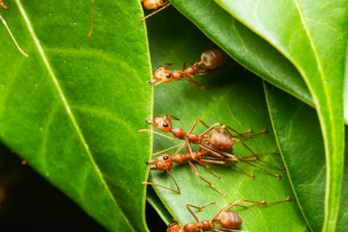 | Weaver ants glue leaves together to make a ___________. The queen ant lays her eggs here.

