Lodges
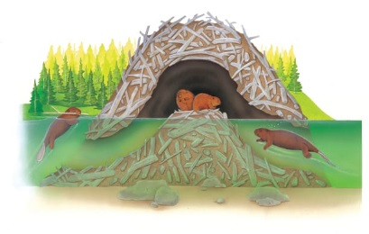 | A family of hard-working ________________ help each other to build a home on the river. They uses branches, sticks, and thick, brown ________. This is what their home looks like above and below the water.
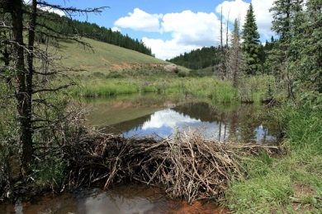 | The beaver family home is called a _____________. It makes a dam across the river.
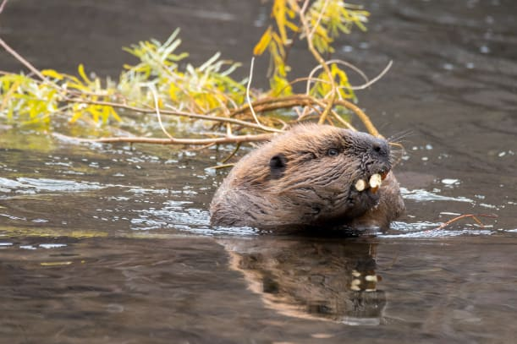 | A beaver carries a _____________ in its mouth.
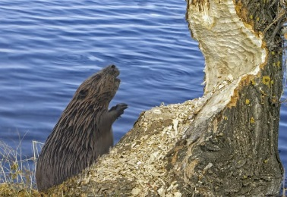 | A beaver gnaws at a tree with its strong front ______________. Before long, the whole tree will fall over. Crash!
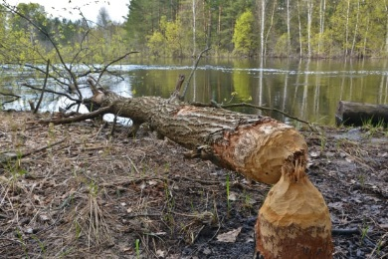 | A beaver nearly always knows which way a tree will ________. When the tree topples, the beaver dashes out of the way!

