Lion
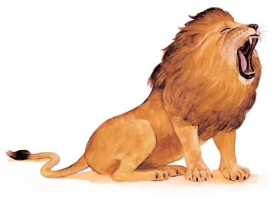 | Lions live together in groups called __________. The females ordinarily do the ______________. They sneak up on their prey and surprise them. After a lion catches a meal, all the members of the pride eat together.
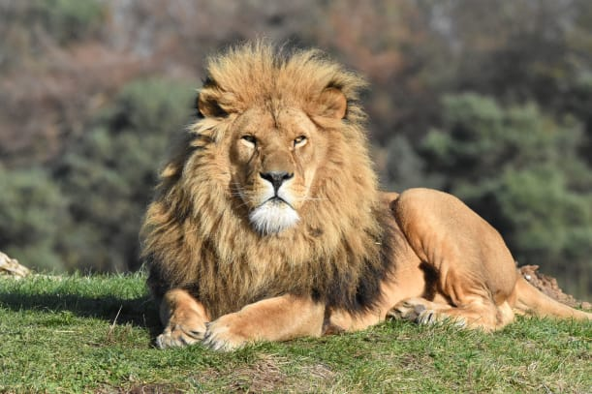 | An adult male lion has a __________. The shaggy mane makes it look big and frightening.
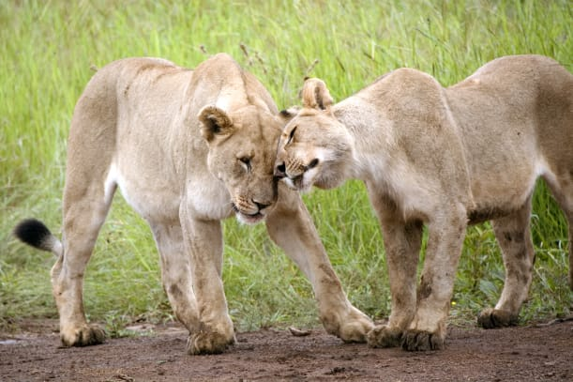 | When a lion meets another lion, they run their ____________ together. This shows they are friends.
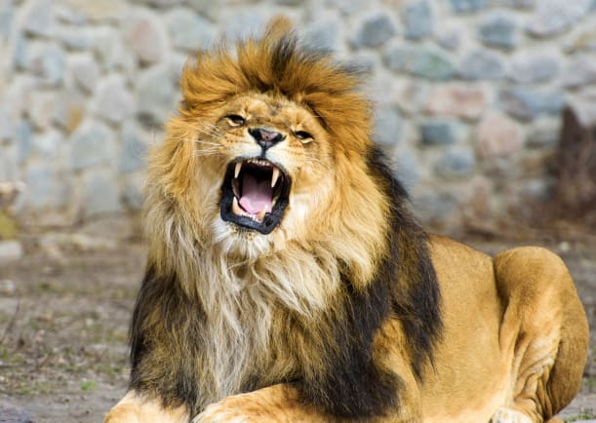 | A mighty _________ frightens other animals away. Lions are called “king of beasts” for their beauty and ___________.
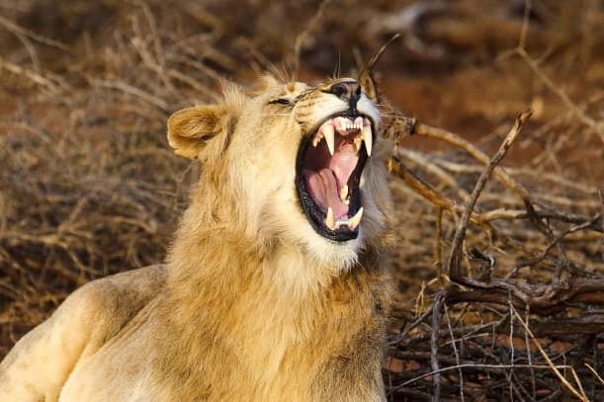 | Lions are fearsome hunters. Sharp ___________ help a lion catch and grip its food.
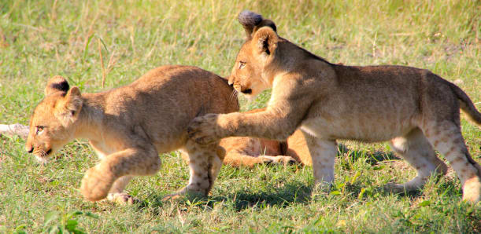 | Baby lions are called _______. Cubs chase each other and wrestle. It’s fun!

