Hot Summer
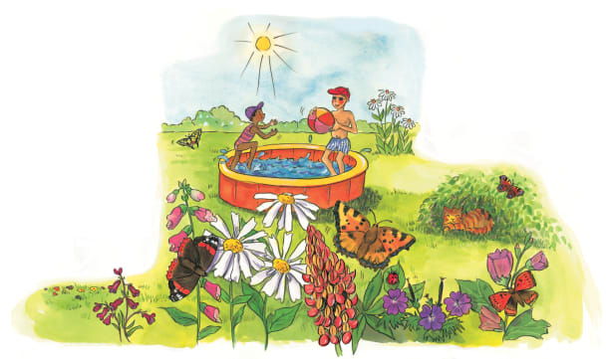 | In summer, the days are ________ and warm. Its fun to play outside when the sun shines brightly and the sky is ________. Bugs buzz and flutter around ___________, which are packed with colourful, scented flowers.
 | The warm golden sunshine helps the flowers ________. Make sure to rub plenty of sun block into your ________. It will protect your skin from the strong sunshine.
 | A ______ and sunglasses protect you from the sun’s hot rays. Splashing in the water is a fun way to keep _________.
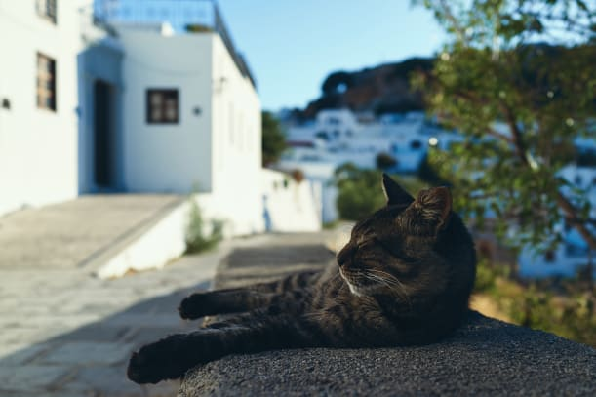 | The cat looks comfortable resting in the cool _____________.

