Honey Bee
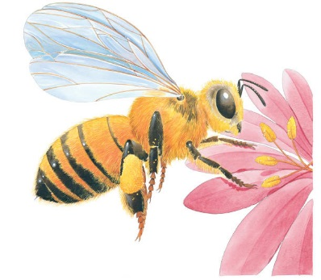 | In summer, a honey bee spends its day flying from flower to follower, collecting a sugary liquid called __________. The bee takes the nectar back to its ________ and turns it into honey. This will be its winter food. Bees also collect a dust called ______________ from the flowers to feed the baby bees in the hives.
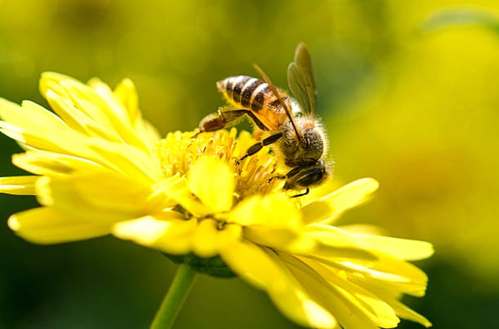 | Honey bees have sharp _______________ that they use to fight off enemies. They can beat their __________ so fast that it makes a buzzing noise! Honey bees have small __________ all over their body that pick up pollen.
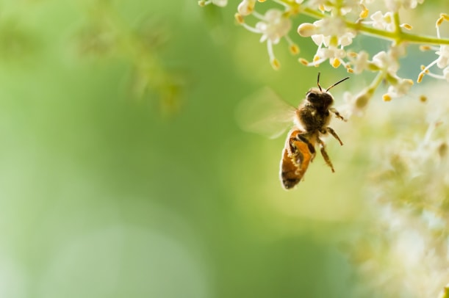 | When a honey bee finds food, it tells the other bees where to go by performing a special _________.
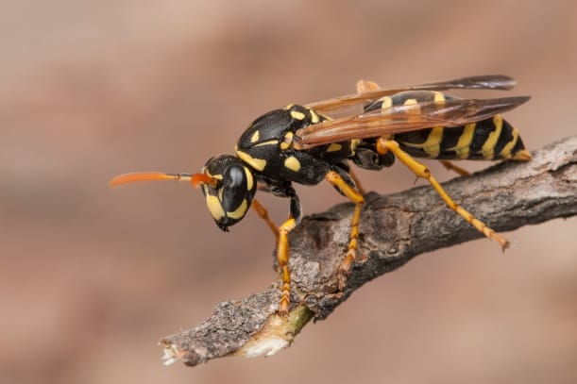 | ____________ are related to bees. Like bees, wasps have bright stripes to warn other animals to stay away.

