Holes and Tunnels
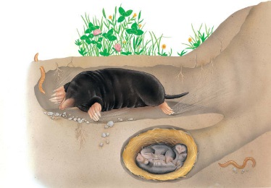 | Deep under the ground in the dark, moles, rabbits, and badgers live in long _______________ and snug holes. This ________ is hard at work, digging and scooping up earth to make its new underground home.
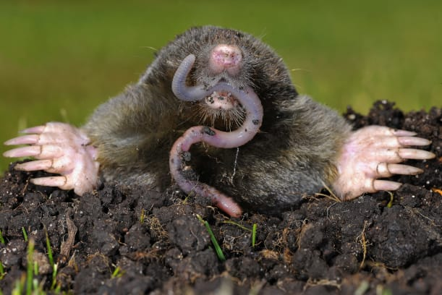 | A mole’s underground tunnel is called a _____________. Inside, there are tasty worms for the mole to eat. Strong ________ shaped like shovels are perfect for moving earth.
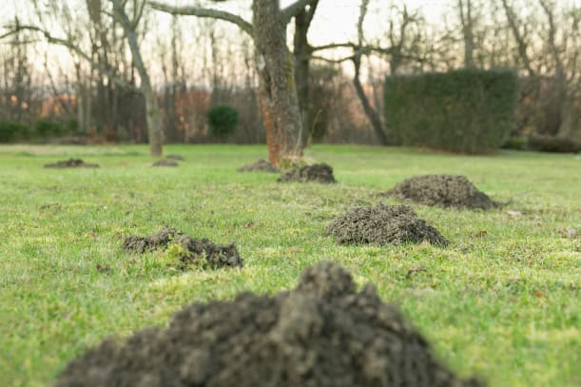 | A mound of earth piles up above the ground by a mole. This is called a _______________.
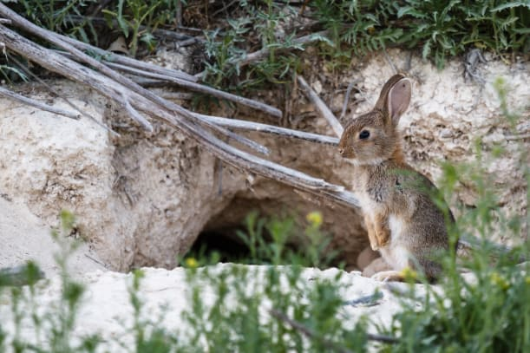 | A rabbit’s underground home is called a ____________. When the coast is clear, the rabbit hops out and nibbles the _______.
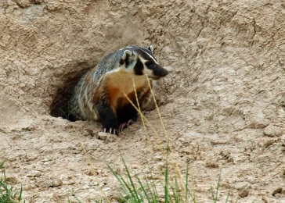 | Badgers ________ burrows to live in, and to escape from danger. Badgers can dig ________.

