Hives and Insect Nests
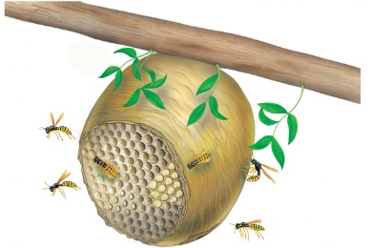 | A wasp nest is home to hundreds of striped wasps. Honey bees live together too, in homes called __________. Inside the hives, the bees make sweet ______________ that is delicious to eat.
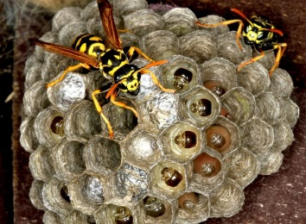 | The queen wasp lays lots of tiny white ________. Each egg has its own special room, called a _________. The eggs hatch into fat grubs that eat all day long!
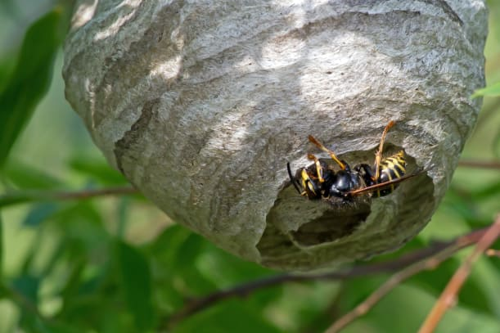 | Worker wasps chew ______________ to make paper to build the __________.
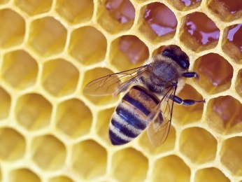 | A honeybee fills the cells in a hive with _______________. When a cell is full, the bee makes a _______ and covers the cell – just like putting a lid on a jar.
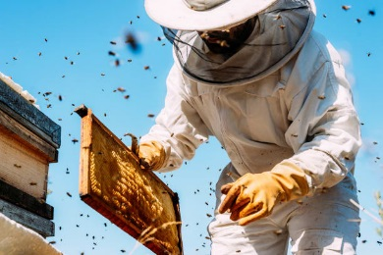 | Every week, a ___________________ visits the hive. He wears a mask and gloves to protect himself from bees’ sharp __________.

