Hippopotamus
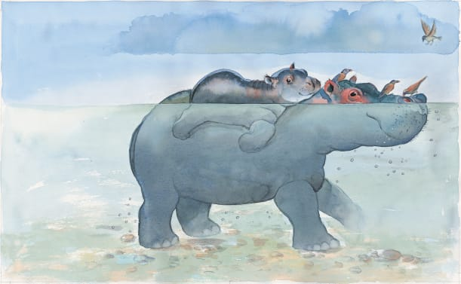 | Hippopotamuses, or ___________ for short, love to spend their days lazing around in muddy _________. There they keep ________ away from the hot sun. At night, they climb onto the ________ to munch grass at the water’s edge.
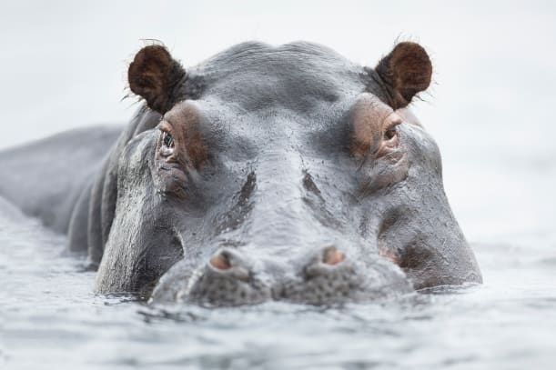 | A hippo enjoys walking along the bottom of the ________. It keeps its ______ just above the water to spot enemies.
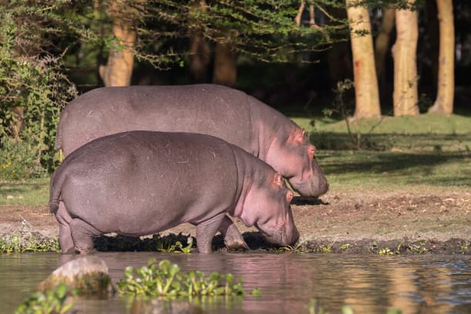 | A hippo turns ________ when it leaves the water. A special ________ makes its skin change colour and helps protect it from the sun.
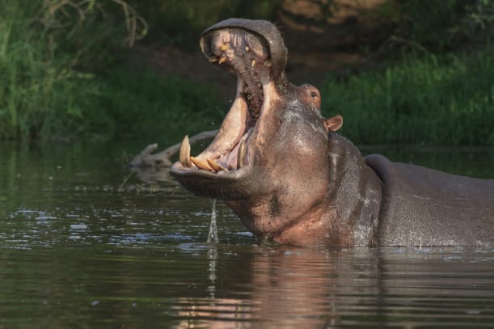 | When a hippo is ________ it opens its big mouth as wide as it can and flashes its long, sharp ___________!
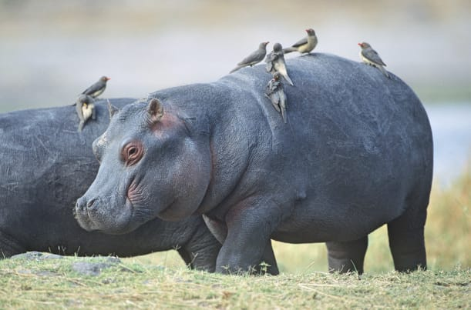 | A hippo has a big heavy body shaped like a round barrel. Small birds pick ___________ off its body, helping to keep it clean.
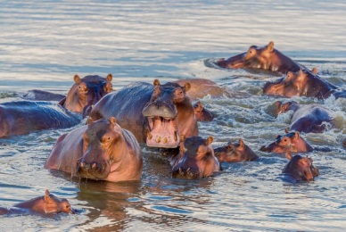 | River hippos live in ___________, or groups, of 5 to 30 animals. A group of hippos is called a “__________”.

