Grasshopper
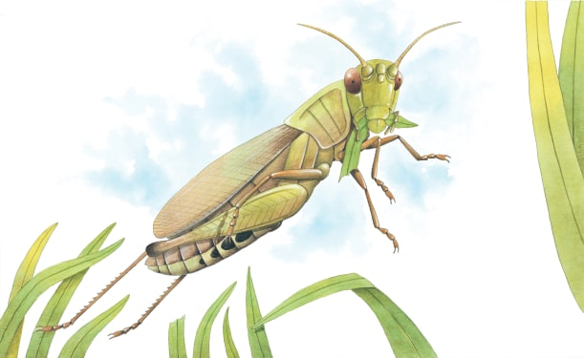 | Grasshoppers live in fields and meadows, where there are plenty of plants to ______. When some grasshoppers spot an enemy, such as a frog, they _______ high into the air to escape. There are over 20,000 types of grasshoppers.
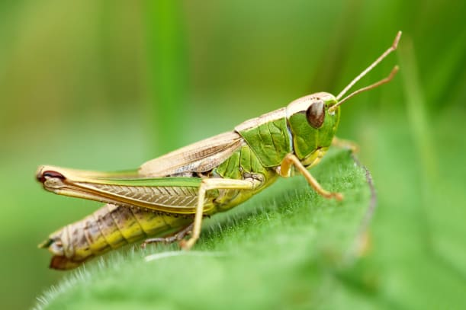 | Powerful back _______ help a grasshopper to push itself off the ground. A grasshopper rubs its back legs against its front _________ to make a chirping sound. A grasshopper’s colour and markings help to make it ________ in well with its surroundings.
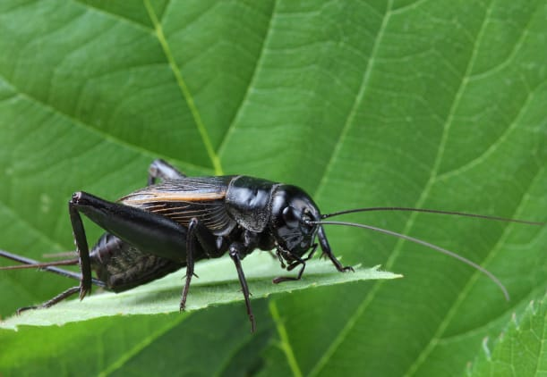 | Crickets are related to grasshoppers. The field cricket’s song changes according to the _____________. The hotter the weather, the ____________ the cricket chirps.
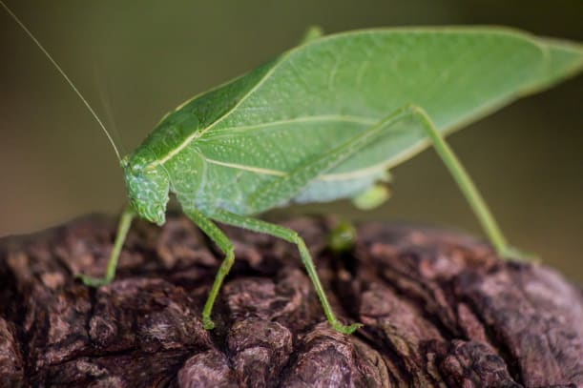 | A katydid is a kind of grasshopper. It gets its name from the ___________ it makes, which sounds like “katydid-katydid!”.

