Giraffe
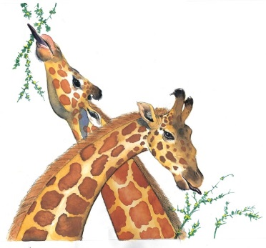 | Small groups of giraffe run across the ________________ on their long, slender legs. They are the _____________ animal in the world. Giraffes aren’t afraid of many animals. But they have to keep an eye out for hungry _________.
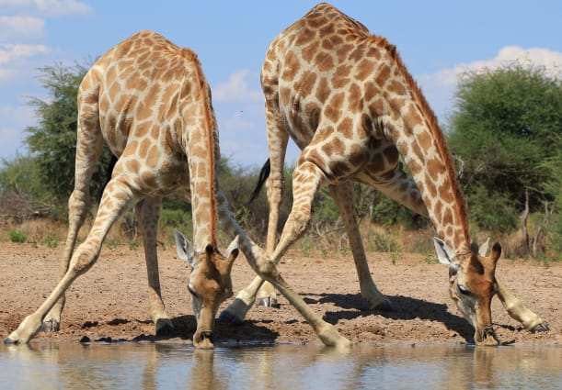 | A giraffe bends down a long way to have a __________. It spreads its front _______ wide and carefully lowers its head.
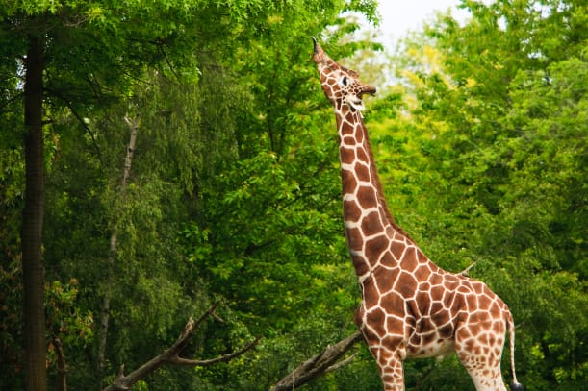 | A giraffe stretches its _________ to reach leaves high in the trees. It pulls leaves from the trees with its thick black ________________.
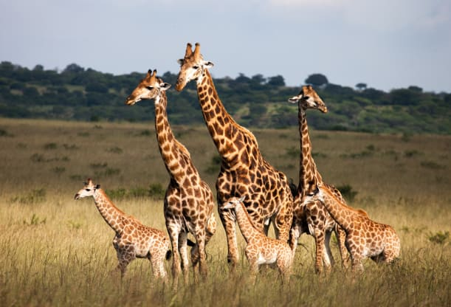 | Patchwork markings help _______ a giraffe among the trees. Each giraffe has a different coat pattern, just as people have different _________________.
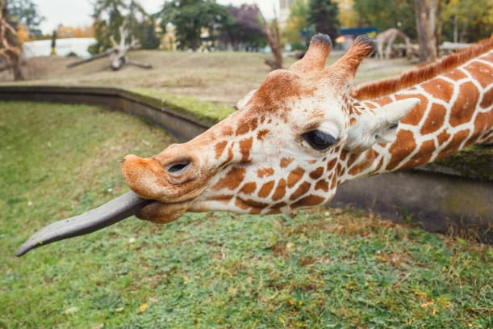 | A giraffe can wrap its long _____________ around its head. It even uses its tongue to wash behind its _______!

