Elephant
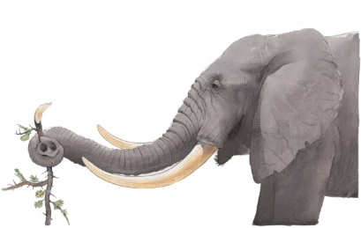 | An elephant has the longest ________ in the world, but uses its nose for more than smelling! An elephant uses its nose, called a _______, for drinking water, carrying food, and making a loud noise just like a trumpet.
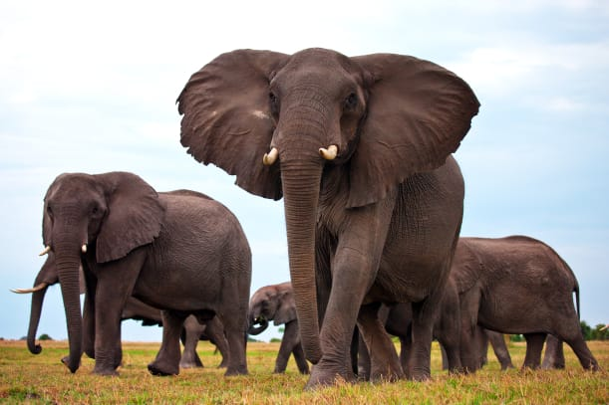 | Elephants are the largest land animals in the world. They live in large groups called __________.
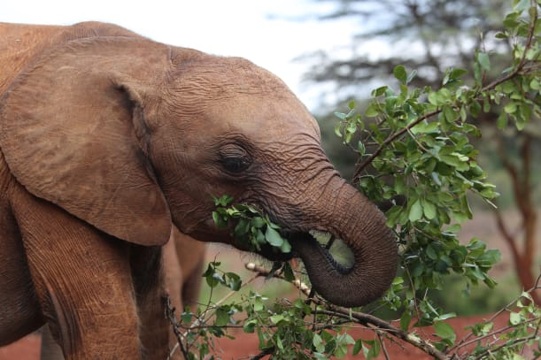 | Elephants spend most of the day ___________. They eat hundreds of pounds of __________ each day.
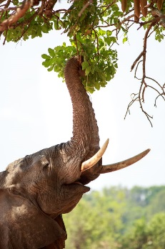 | An elephant sniffs its food through two __________ to find out if it is good to eat. The _________ is also useful for pulling tasty twigs off trees.
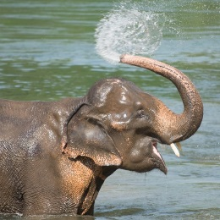 | An elephant likes to take a shower. It sucks up ___________ through its trunk. Then it squirts water all over its body.
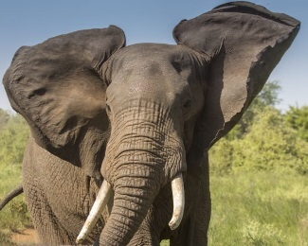 | Elephants have large _______. When an elephant is _______, it flaps its huge ears to cool down.

