Dragon Fly
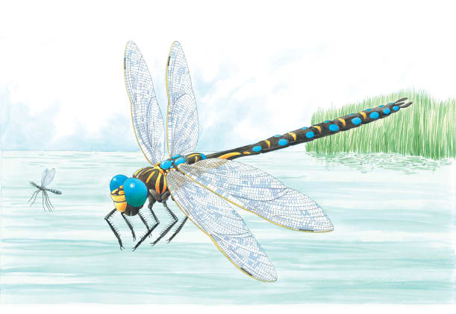 | Colourful dragonflies often are found near streams and __________. They are fast _________, and they fly up, down, forward, and backward. They can hover, or stay in one place in the air, like a helicopter! Dragonflies hunt in the _______ by darting out to grab other flying insects.
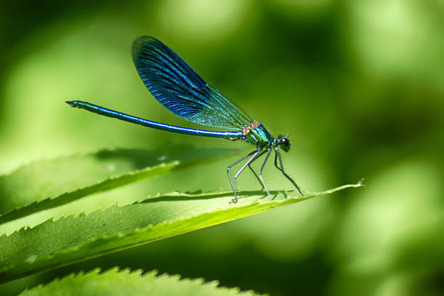 | Huge ________ help dragonflies spot their prey. They have four large ________ that help hover. Dragonflies have long, thin bodies that help them _____________ as they fly around.
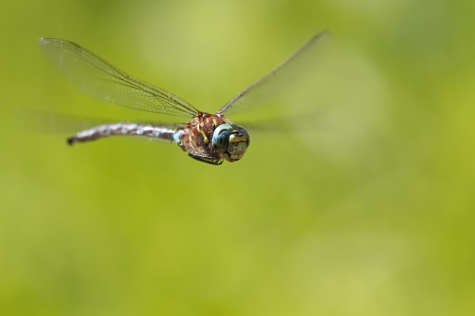 | The dragonfly is one of the _______________ insects. It can reach speeds of up to 61 kilometres per hour!
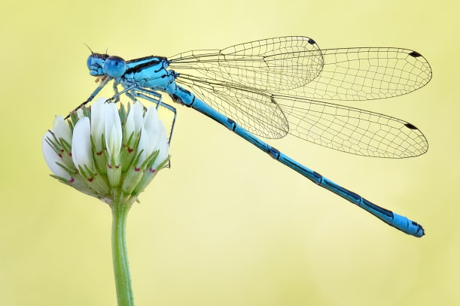 | The damesfly is related to the dragonfly. It lives ___________________ at the start of its life and on land when it is fully grown.

