Dolphin and Whale
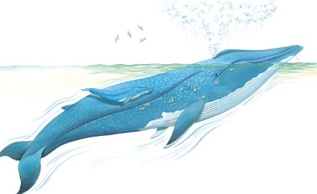 | Dolphins and whales are animals that live in the ____________. They are _______________, not fish. They feed their young with _________ produced by the mother. They also swim up to the surface to ___________, then dive below with a splash.
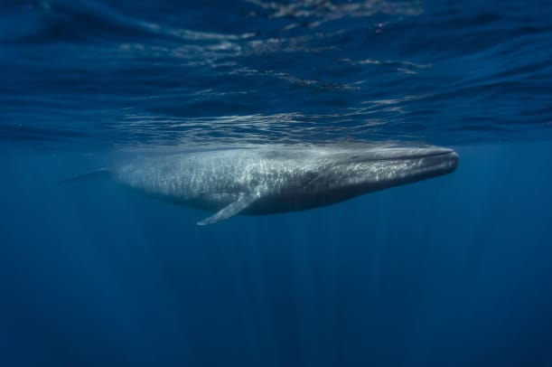 | The largest animal that has ever lived is the _______ ___________. A grown blue whale is as long as a row of five elephants!
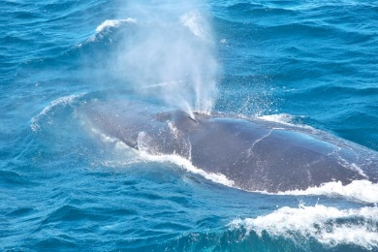 | A whale breathes by sucking in air through one or two _________________ on top of its head. When a whale breathes out, a spout of misty spray shoots high into the sky.
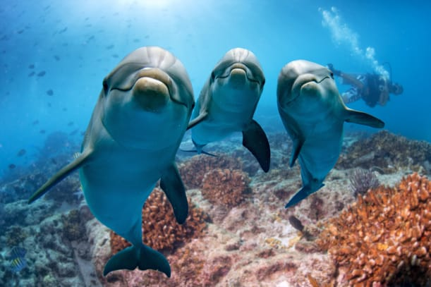 | Dolphins often play together. They swim in groups and make clicking ______________.
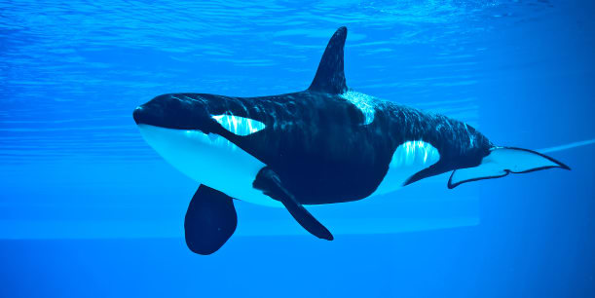 | Despite their name, killer whales are actually _______________. They are the largest kind of dolphin. A killer whale is also called an ____________.

