Diplodocus
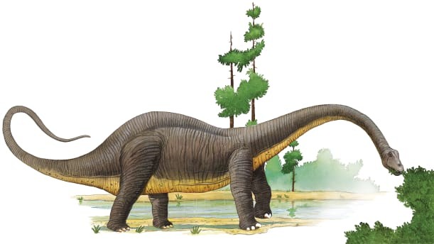 | Millions of years ago, the world was a warm, wet place. Tall trees, steamy _________, and thick bushes covered the ground. Huge creatures called _________________ roamed the land. The Diplodocus, shown here, was one of the ________________ dinosaurs.
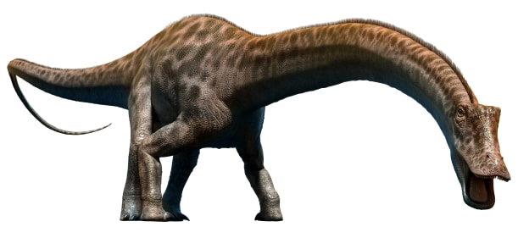 | Diplodocus had four sturdy ______ to hold up its heavy body. It used its tail like a _________ to swipe at its enemies.
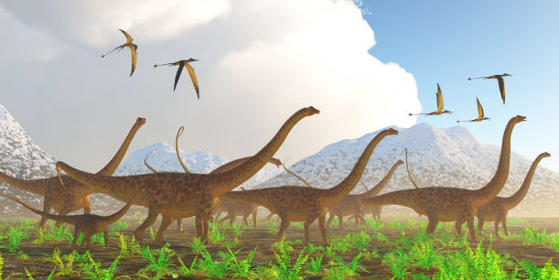 | Diplodocus had a small head and long ________. It held its long neck out in front of its body.
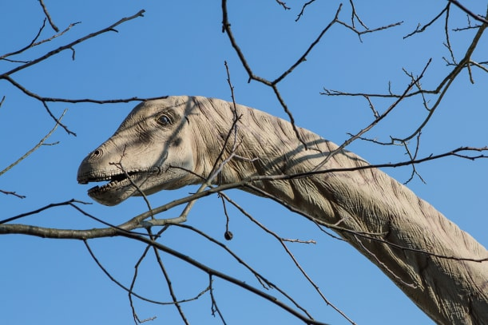 | Diplodocus was a gigantic _________ eater. It ate huge amounts of ________ with its peglike teeth.

