Dens
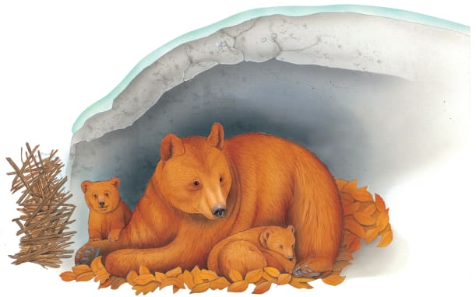 | Many animals make secret hideaway homes in rocky caves or hollow tree _________. These homes are called _______. A grizzly bear and its young are inside their warm _________.
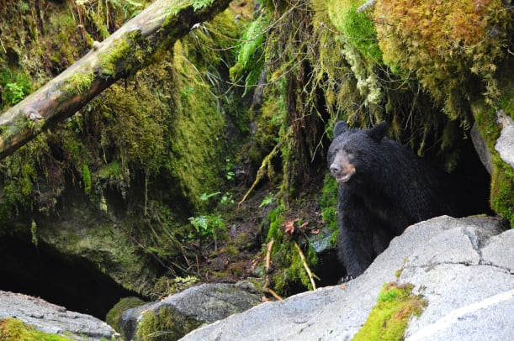 | This bear is coming out of its cave after a long ____________ nap. The rocky walls of a cave keep out __________ and wind.
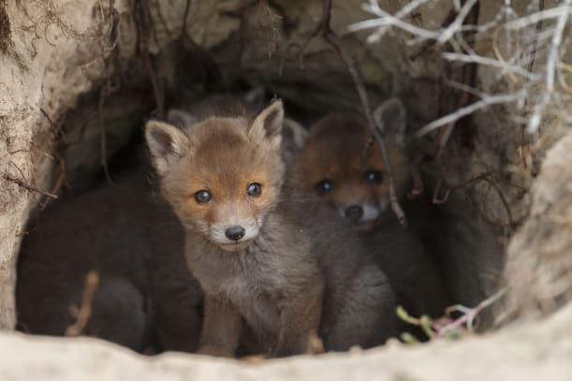 | Young __________ peek out of their den. In springtime, it’s warm enough to come out and play!
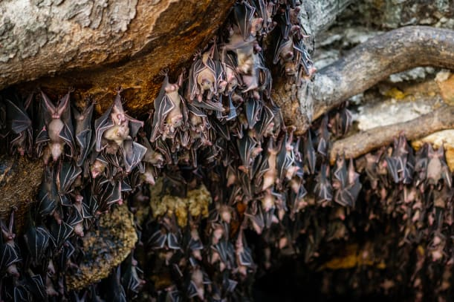 | Groups of bats live in caves. They ___________ here all day long, hanging upside down. It’s a tight squeeze!

