Crab
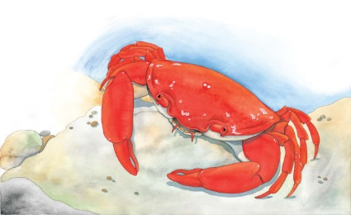 | Crabs can be as small as a pea or as big as a dinner plate. They scuttle quickly over the seabed or scurry across the __________. When danger is near, they burrow into the ________ or hide under a rock.
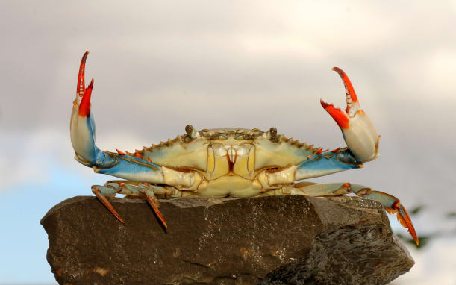 | Crabs have strong _________ for crushing food and fighting off attackers. A thick, round shell protects a crab’s back like a coat of armour.
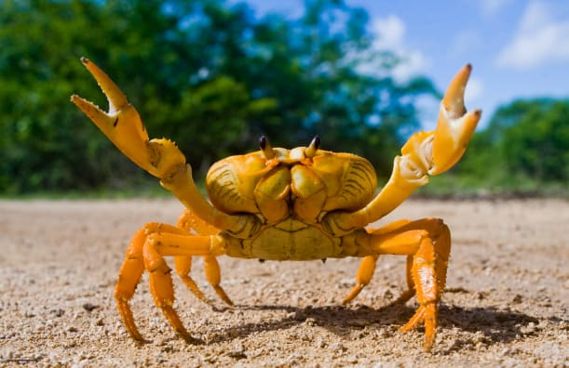 | A crab has five pairs of _________. The first pair is tipped with large _________. Crabs walk or run sideways.
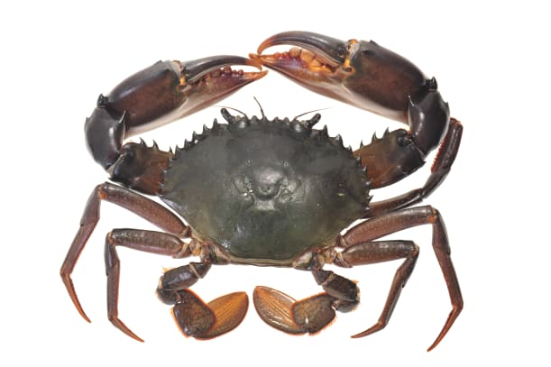 | A crab can grow too big for its __________. When it does, the old shell cracks open. A new, larger shell grows underneath.
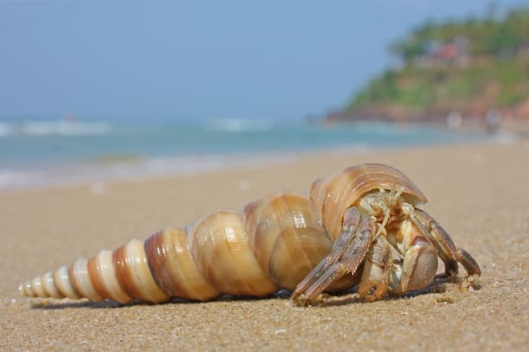 | A hermit crab has no shell of its own. It makes its home in a ____________ left behind by another creature.

