Cool Autumn
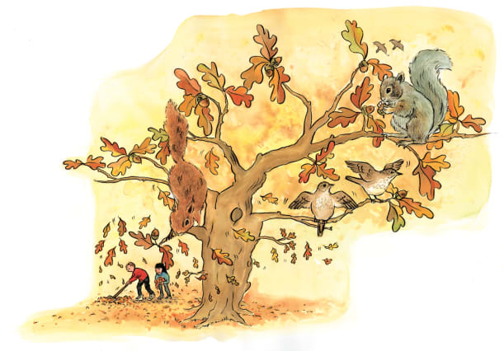 | On an autumn day, it’s fresh and cool, even when the sun _________. Trees lose their ___________, fruit ripens, and animals prepare for the cold winter months. Early in the morning, the air may feel ________.
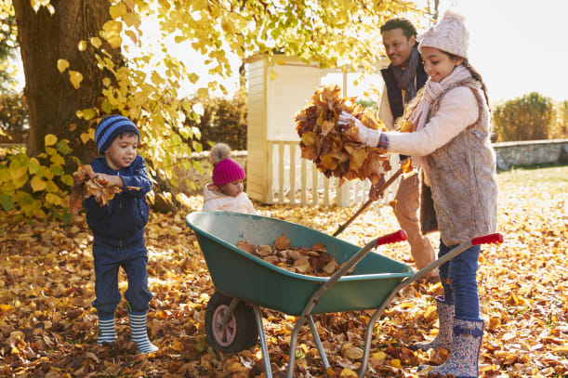 | Colourful ______________ fall from branches. It’s fun to rake leaves that have fallen from the tree.
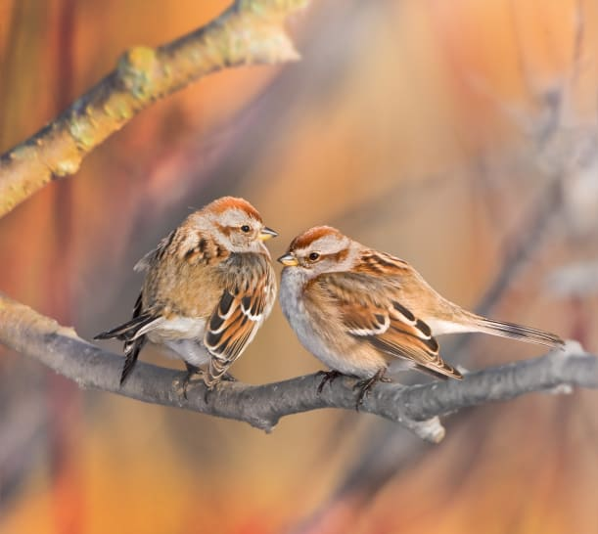 | There are tasty ______ for animals to eat. These _________ are about to fly to a warmer place far away. They’ll return in the _______________.
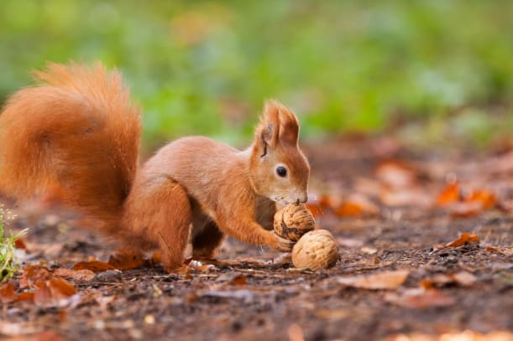 | Squirrels collect _______. They store them, then eat them during the cold ____________. Squirrels _______ nuts for the winter in all kinds of nooks and crannies, but sometimes they forget where they put the nuts!

