Colourful Fish
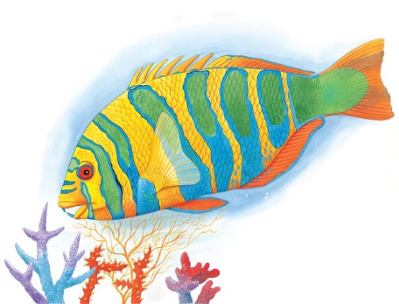 | Thousands of colourful fish dart in and out of a _________ reef. The water is warm and sunny, and there is plenty to eat. There are also good places to _______ from larger creatures that are looking for a meal.
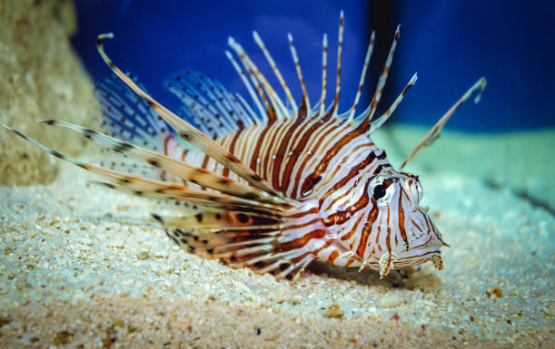 | A lion fish scares its enemies away. Red __________ and prickly spines on its body make it look extremely fierce.
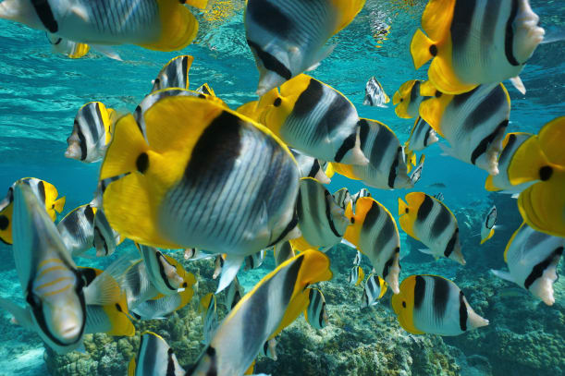 | To stay safe, butterflyfish swim in a _________. It is difficult for enemies to tell where one fish ends and another fish begins.
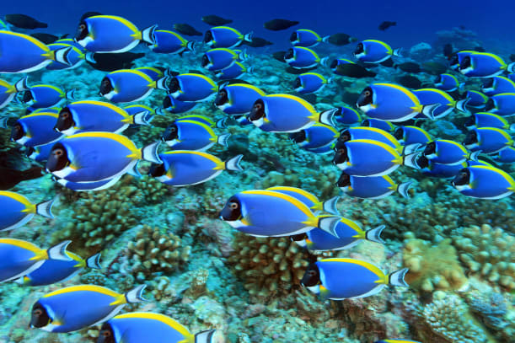 | ____________ grow in beautiful shapes and colours. Some fish have bright _____________. They make it hard for an enemy to spot them among the corals.
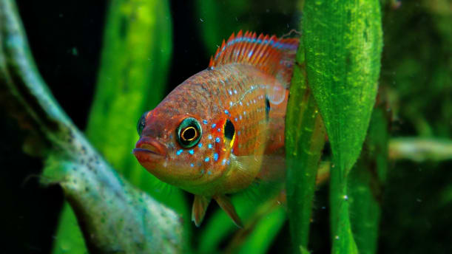 | Slimy _________ help a fish to glide smoothly through the water. A thin __________ can slip easily into narrow hiding places.

