Cold Winter
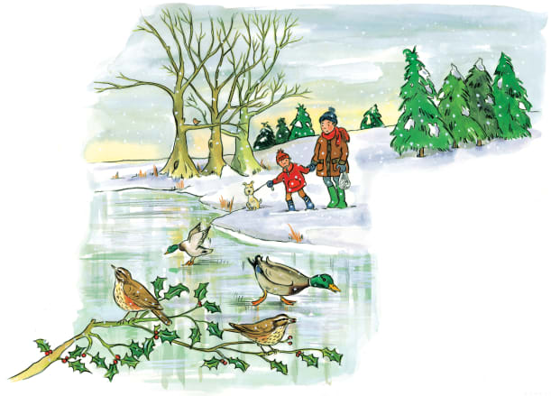 | In winter, days are ________, and nights are long. The sun’s _______ are weak, and the weather turns cold. Many animals ________ until the warm spring. Others are up and about during the cold weather.
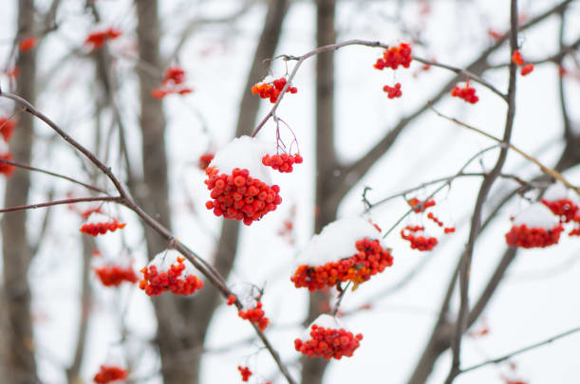 | There are many ______ trees in winter. The ___________ fell off the trees in autumn. There is little food for birds to eat, except winter ____________.
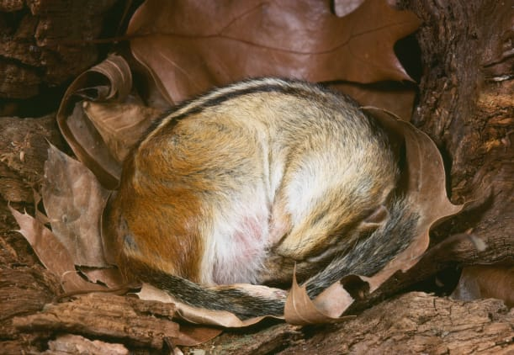 | It’s so cold that the water in this pond has _____________ into ice. Some animals sleep through the cold winter months in their cosy _________ and homes. They won’t wake up until the warm _____________ arrives.
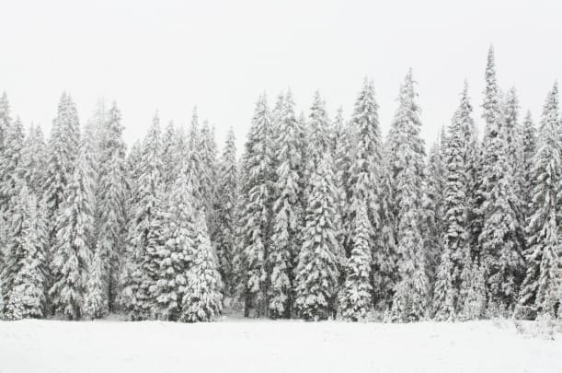 | Even in freezing ___________, pine trees keep their leaves, called needles.

