Clouds and Rain
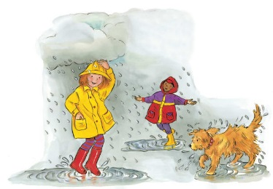 | Look up at the sky! Can you see any __________? Are they white and fluffy or dark and gloomy? Clouds are made up of tiny drops of ____________. The drops grow bigger and heavier until they fall to the ground. It’s _____________!
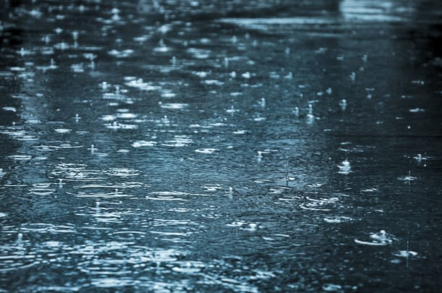 | When it pours rain, puddles of __________ are left on the ground. Can you see the wavy ripples in the water?
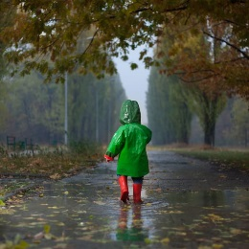 | Splish, splash! Lots of raindrops fall onto your head. A ____________________ keeps out the water. Inside, you stay cosy and dry. Watch out for splashes!
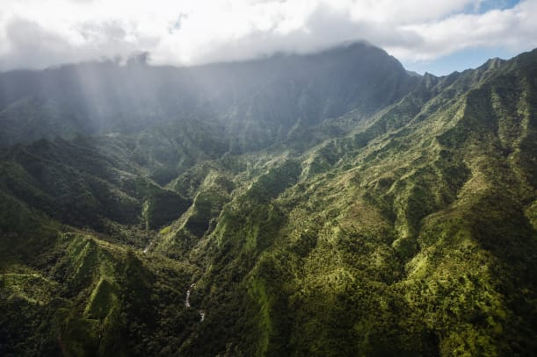 | One of the rainiest places on Earth is a _______________ in Hawaii. All of the rain that falls there in a year would cover a three- storey building.
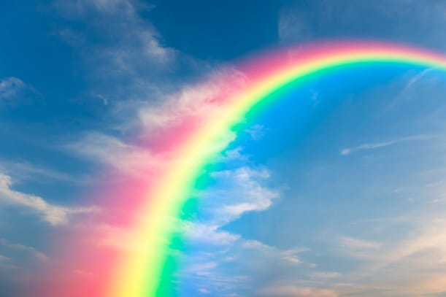 | This beautiful band of colours is called a ___________________. It appears when there is rain and _____________ at the same time.
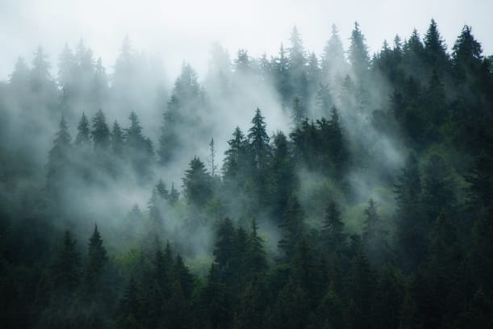 | _______ is like a cloud that touches the ground! On a foggy day, it’s hard to see far in front of you.

