Chimpanzee
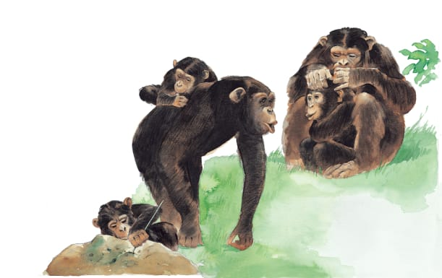 | Chimpanzees, or __________ for short, live in noisy groups. They look after on another and search for __________ together. When they are excited, they jump up and down and __________ as loudly as they can.
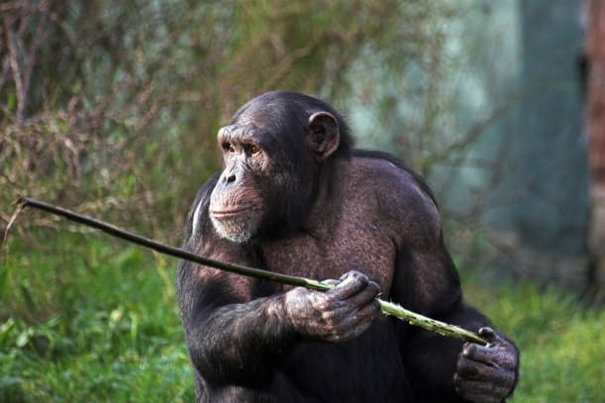 | Chimpanzees are smart and can make simple _________. A stick is useful for digging up _____________.
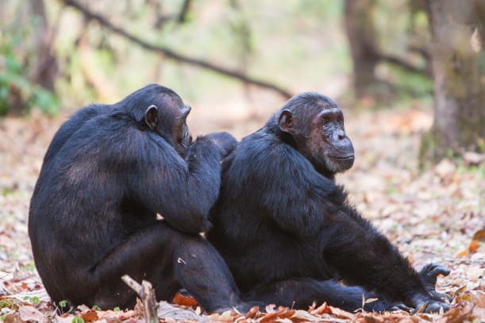 | Chimpanzees spend many hours a day in a friendly activity called _______________. During this time, they sit together and pick through each other’s ________.
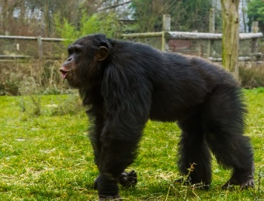 | A chimpanzee walks on all __________, leaning on its knuckles. They also can stand up and walk a short way on _______ legs.
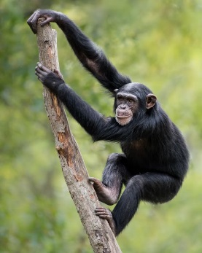 | Young chimpanzees enjoy playing in the _________. They grip the branches tightly with their _________ and feet.
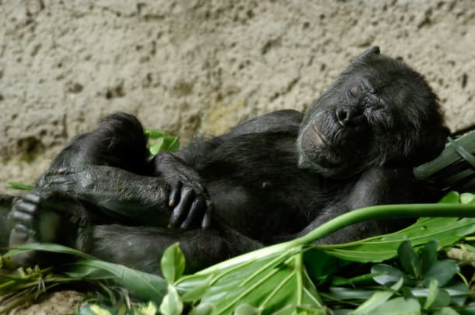 | A chimpanzee makes its own bed! Each night, it climbs up a _______ and makes a bed of _________ and leaves. Time for sleep!

