Cheetah
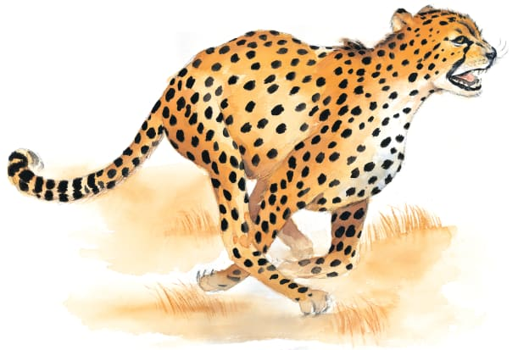 | During the day, a sneaky cheetah _________ for its dinner. It spots an animal from far away and follows it silently through the _________. Then the cheetah leaps out and _________ it as fast as it can. In second, the cheetah has a tasty meal!
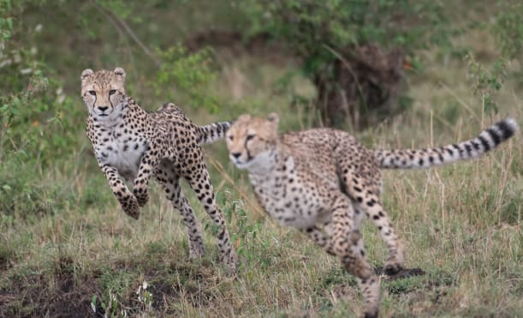 | A cheetah runs ____________ than any other animal on land. Over short distances, it runs as fast as a ______ on a highway!
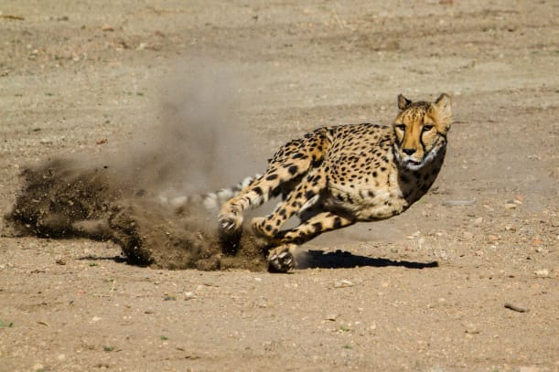 | A cheetah’s long legs are built for _______________ quickly. Its strong _________ dig into the hard ground helping it run fast.
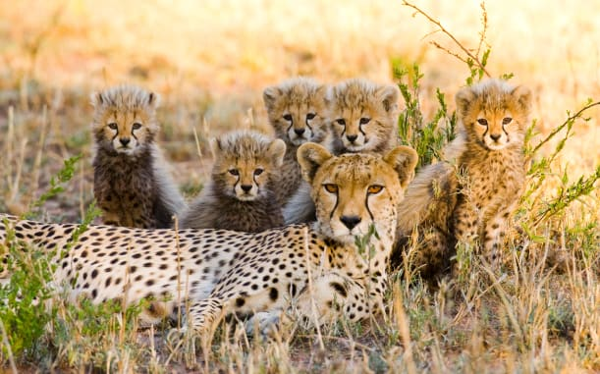 | A mother cheetah looks after her ________ for many months. She teaches them how to live in the wild.
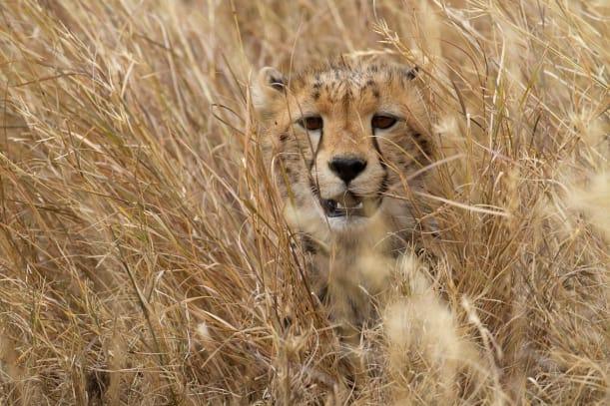 | Cheetahs have ________ coats with _______ spots. These spots ________ a cheetah as it moves through the grass.

