Changing Seasons
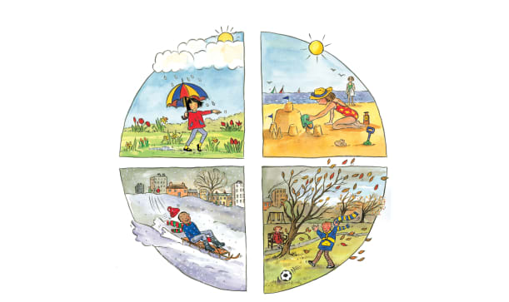 | Some places have four _____________ called spring, summer, autumn, and winter. Each season brings its own kind of weather. As the weather warms up and cools down, look out for all kinds of ________________ that happen.
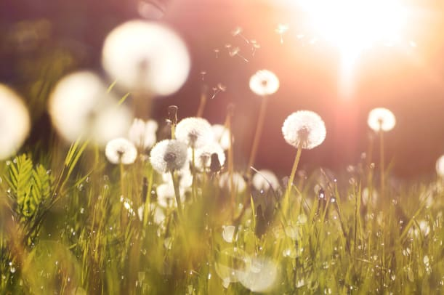 | In ______________, there are lots of rain showers and new ____________. The sun begins to shine more warmly, too.  In __________________, the sun is high in the sky and shines brightly. This is the ________________ time of the year.
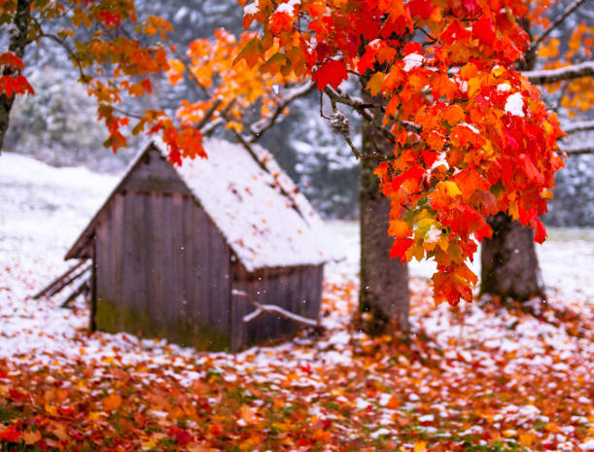 | In _______________, some leaves change colours and the days turn cooler.  In _______________, it may start to snow. This is the coldest time of the year.
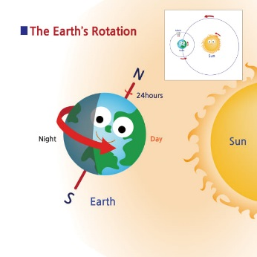 | When it’s ______________ and chilly in the _____ half of the world, its _____________ and sunny in the ______________ half of the world.
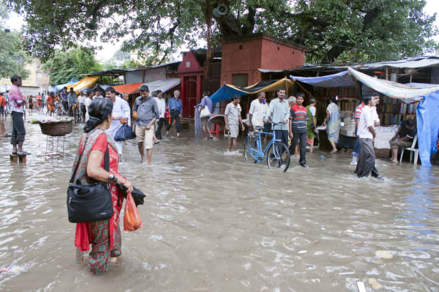 | Some countries only have ________ seasons, one dry and one __________. In the rainy season, it can pour for months.

