Butterfly
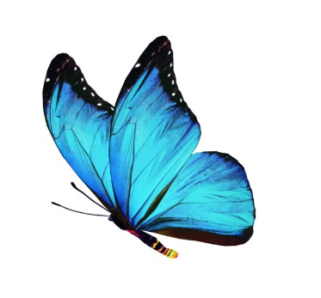 | Most insects can ______. A butterfly has large, colourful ________. Like all insects, a butterfly starts life as a tiny _______, but it goes through many changes before it becomes an adult. The life cycle of a blue ___________ butterfly is shown here.
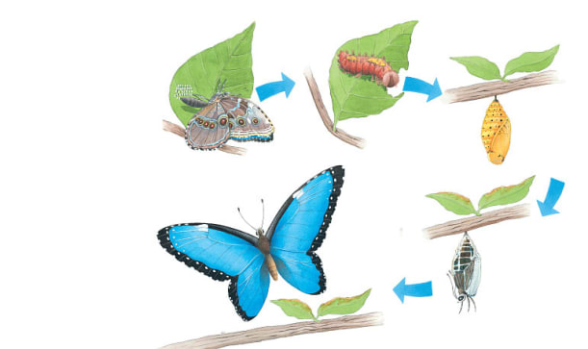 | Mother butterflies lay _______. _______________ hatch from those eggs. When caterpillars get big enough, it forms a _____________. A new butterfly forms inside the hard shell of the chrysalis.
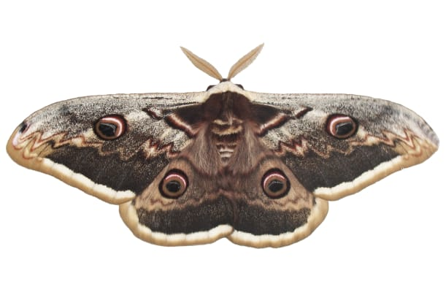 | __________ are related to butterflies. But a moth’s body is big and furry. Its _________________ look a bit like feathers!

