Birds’ Nests
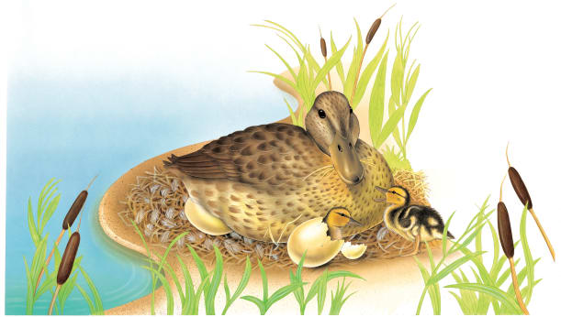 | In spring, birds build comfortable nests, where they lay _________. Soon the eggs hatch into hungry, noisy baby birds. The nest is ____________ to the baby birds until they grow strong enough to look after themselves.
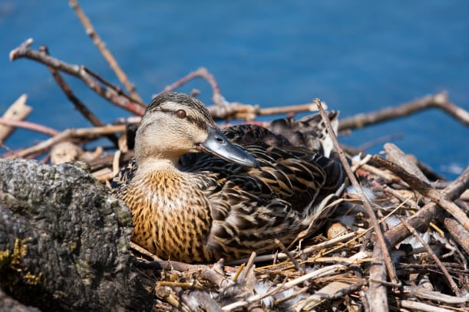 | A mother duck builds her nest near the edge of a __________. Soft, fluffy _______________ line the nest.
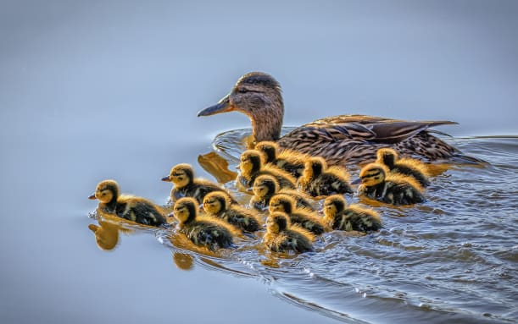 | A baby duck is called a _________________.
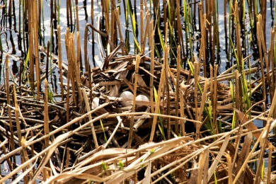 | Tall ________________ grow around a nest.
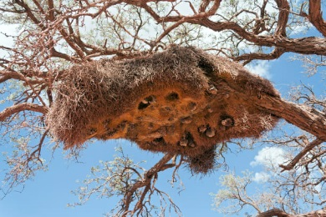 | Friendly birds called __________________ live in apartments. Together, they build a big grassy nest with a ______________________ for each bird.
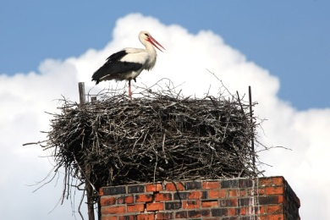 | A ___________ builds a huge nest that it returns to every year. This stork’s nest is perched on top of a tall ______________.

