Beetle
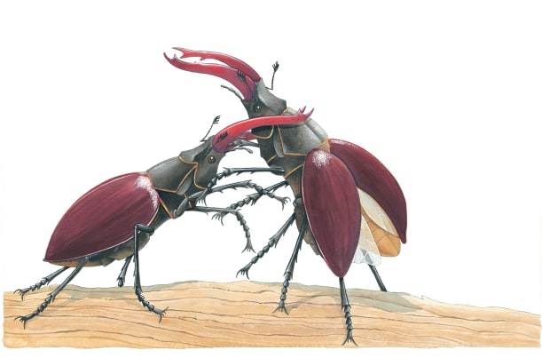 | There are thousands of different beetles in the world. They come in many colours, shapes and ________. Beetles are tough insects, with hard coverings called _________ cases on their backs. Beetles spend much of their time crawling on the ground. They either run or ______ away to escape from danger.
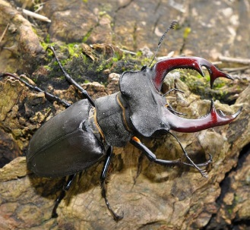 | This is a male giant stag beetle. A male stag beetle has huge _______ that look a bit like deer’s antlers.
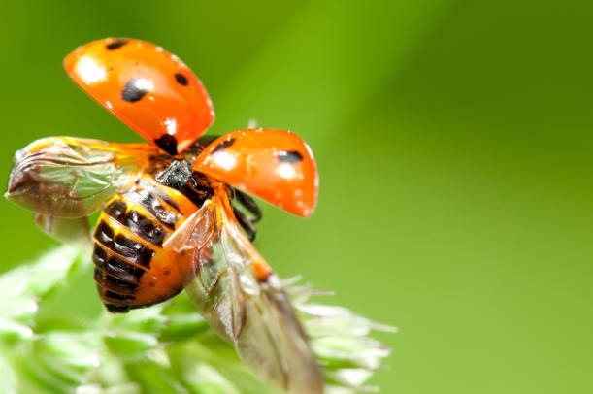 | Beetles have _________. They are kept safe underneath the beetle’s hard wing cases.
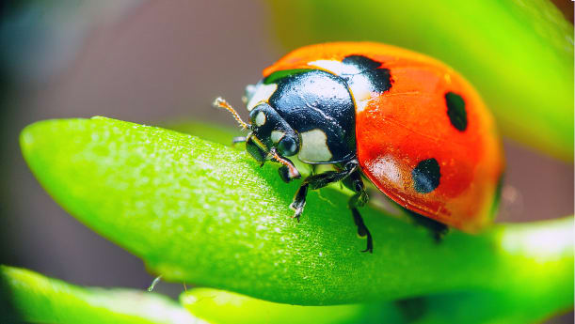 | Ladybugs are a helpful kind of beetle. They eat ________ that feed on garden flowers and farm crops. Oh, and remember: not all ladybugs are ladies!
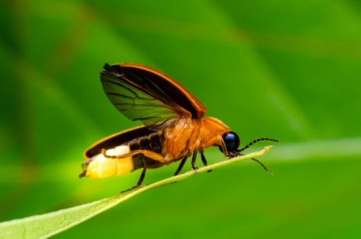 | A firefly is a kind of beetle that makes flashing or glowing _________. The male uses his light to attract a female.

