Ant
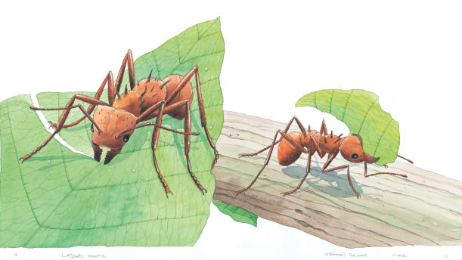 | Lift up a stone or a log, and you may see tiny ants scurrying around. There are many different kinds of ants. Most live together in large groups called ____________. Ants work hard as a team, building ________, collecting food, and fighting enemies.
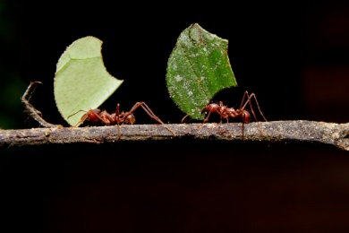 | Let’s take a look at the ________-_________ ant! It lives on the damp floor of the ______ ___________. Workers use their strong _______ to cut leaves.
 | Some ants are very _________. They can lift objects up to 30 times heavier than _____________. That’s like you lifting up a small car!
Use the blank box to draw an ant.

