Ankylosaurus
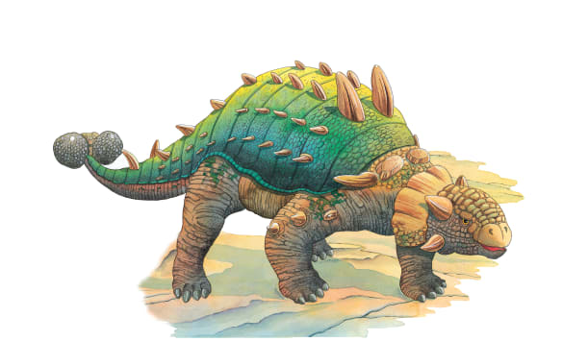 | Ankylosaurus had a clever way of _____________ itself. Tough skin and bony _______ covered all of its body except for its ________. No matter how hard they tried, most hungry enemies could not get past this suit of __________.
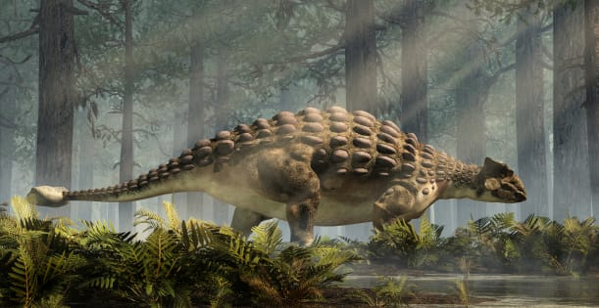 | Thick, hard, bumpy ________ covered Ankylosaurus’s large body. The sharp _________ kept other dinosaurs from coming too close.
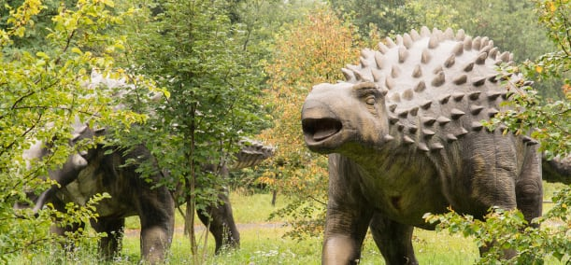 | Ankylosaurus used its small __________ and teeth to much soft ___________.
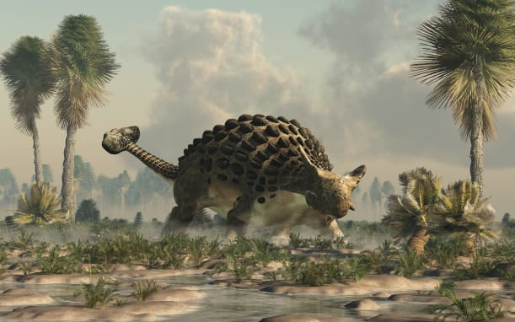 | Ankylosaurus’s tail ended in a big, heavy ball of __________. This knobby club at the end of the tail sent enemies flying!

