Amazing Birds
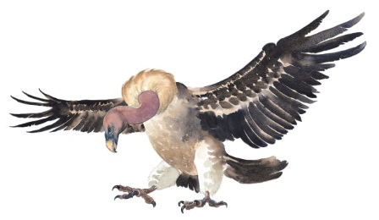 | There are hundreds of amazing birds on the _______________. Giant ostriches run along the ground. Tiny, colourful weavers fly from tree to tree. You may even spot a hungry _______________ swooping through the sky.
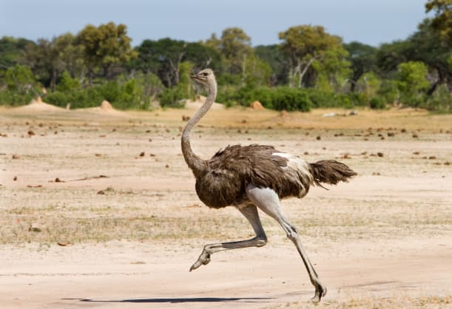 | Ostriches cannot ______. But, they can ______ very fast on their long legs.
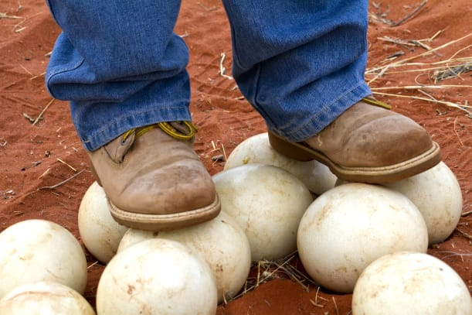 | An ostrich lays the strongest ______ in the world. If you stand on an egg (or, even jump up and down on one!), it still won’t __________.
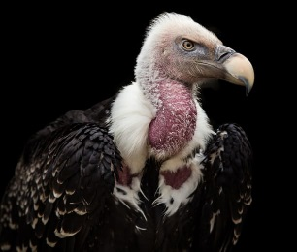 | Vultures are birds that have good ___________________. They can spot a snack from far away.
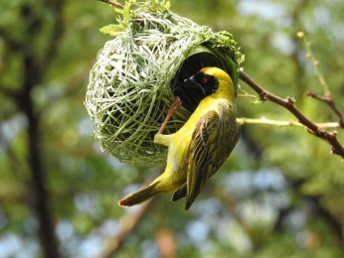 | A weaver bird works hard to build its _______. It collects strips of ________ and weaves them into a nest on a branch.

