Allosaurus
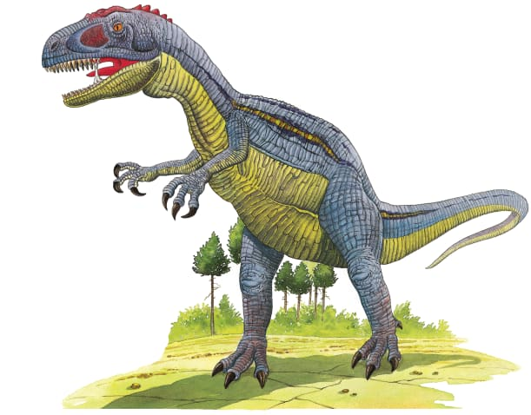 | When fierce Allosaurus came charging through the trees, most other dinosaurs ran for their lives. Allosaurus liked to dine on gentle, ________-eating dinosaurs. It has about 70 jagged teeth for eating _________.
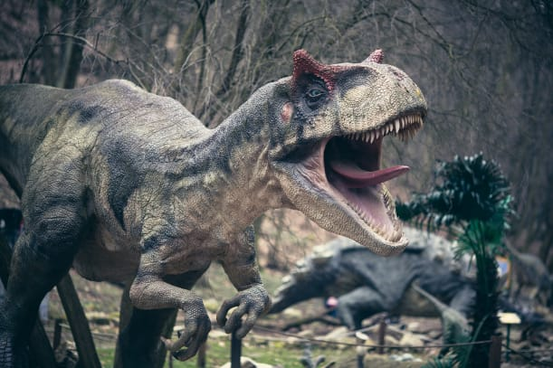 | Allosaurs’s huge head was a terrifying sight! Its _______ probably sounded like a roar of thunder.
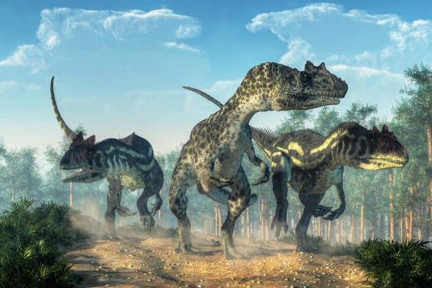 | Allosaurus walked on two thick powerful ______. Its short arms had strong, curved __________.
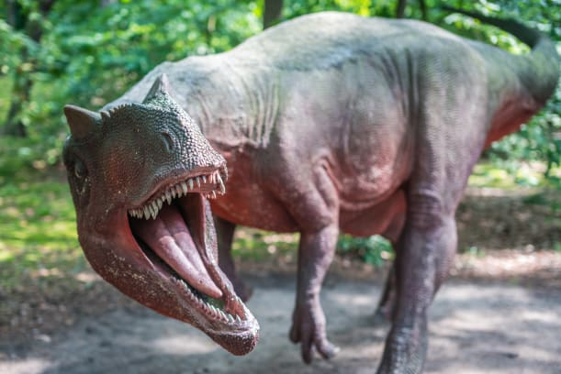 | Allosaurus ate other dinosaurs. Its sharp, jagged ___________ could easily slice through flesh. It fed on dinosaurs that ate plants.

