World Book Kids Compare Places
Go to http://www.worldbookonline.com
Click on “Kids.” Log on with ID and password if asked.

Learn how you can compare New Zealand with Japan, the host nation of the 2020 Summer Olympics.

• Click on the Compare Places button
• Click on the Countries button to compare New Zealand with Japan
1. To choose New Zealand, click on the flag.  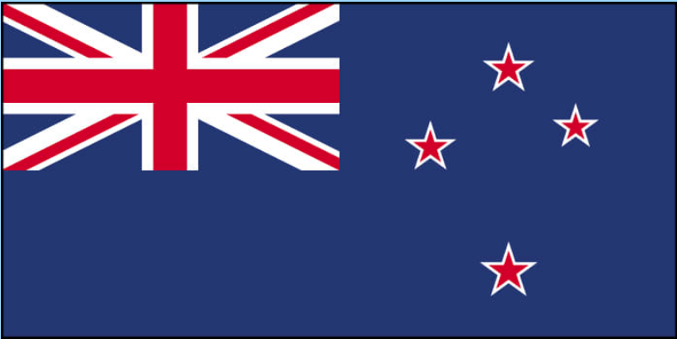 | 2. Search for Japan using the arrows, click on the flag.  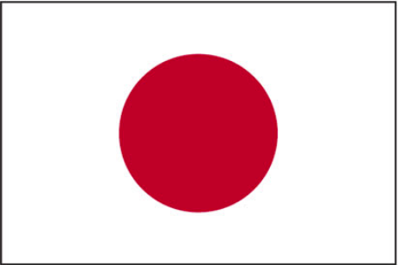

3. Click the Compare Now! button to compare both countries.

Find It!

Find the answers to the questions using the slide bar to scroll down the list.
- Which country has the largest population? ___________________________________________
- Japan is found on which continent? ________________________________________________
- The capital of New Zealand is _____________________________________________________
- The capital of the Japan is _______________________________________________________
- The highest mountain in New Zealand is ____________________________________________
- The highest mountain in Japan is __________________________________________________
- Name one famous place in New Zealand ____________________________________________
- Name one famous place in Japan __________________________________________________

Learn more:
- The Japanese call their country Nippon or Nihon, meaning "source of the sun."
https://www.worldbookonline.com/kids/home#article/ar831063
- The 2020 Olympic Games will take place in the city of Tokyo. Tokyo is one of the busiest and most crowded cities in the world.
https://www.worldbookonline.com/kids/home#article/ar831496

- Colour the New Zealand flag - https://www.worldbookonline.com/kids/home#article/ar842804
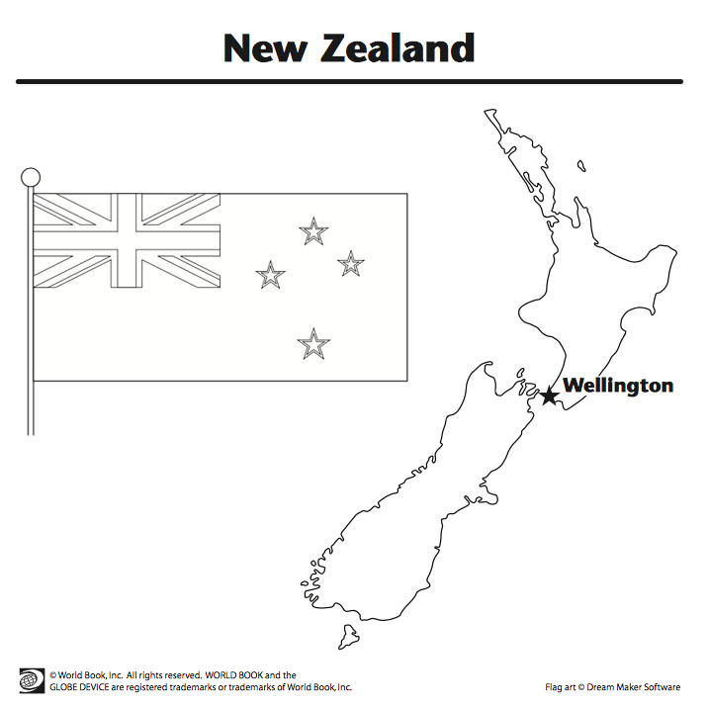
- Colour the Japan flag - https://www.worldbookonline.com/kids/home#article/ar842783
