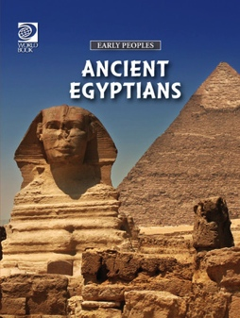
EARLY PEOPLES –
Ancient Egyptians
Activity Sheet

Dictionary: Click or tap and hold on the selected word. Then select the Dictionary option from the Quick Menu to see the word's definition.
Glossary: There is a glossary on pages 60-61. Terms defined in the glossary are in bold type on their first appearance on any spread (two facing pages).
Find the answers to the Matching exercise using the Glossary.
MATCHING: Match the word to the meaning.
Answers: | Word: |  | Meaning:
 | 1. Sphinx |  | A. | A form of writing using pictures.
 | 2. Cataracts |  | B. | Stone figure with human head and lion’s body.
 | 3. Pharaoh |  | C. | A kind of paper used by ancient Egyptians.
 | 4. Viziers |  | D. | Kept the written record of the Egyptian people.
 | 5. Nilometer |  | E. | Stretches of rocky rapids or waterfalls in a river.
 | 6. Osiris |  | F. | The pharaoh’s chief minister and official.
 | 7. Mummification |  | G. | Process of preserving a dead body of a king or other important person.
 | 8. Hieroglyphics |  | H. | Egyptian king, the most important and powerful person in ancient Egypt.
 | 9. Scribes |  | I. | Egyptian god of the afterlife and death.
 | 10. Papyrus |  | J. | Steps cut in river to measure the water level of the Nile.
11. Go to Chapter: WHO WERE THE ANCIENT EGYPTIANS?
Match Egyptian ruler's name with the correct image displayed.
a.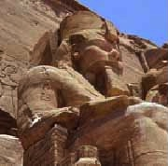 |  | b.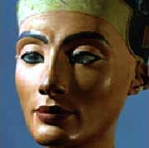 |  | c.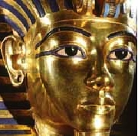 |  | d.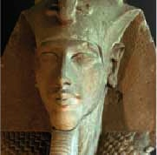 |  | e. 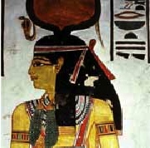
 | Nefertari |  | Akhenaten |  | Ramses II |  | Tutankhamun |  | Nefertiti

MULTIPLE CHOICE: (Circle the correct answer.)
11. Go to Chapter: WHERE DID THE ANCIENT EGYPTIANS LIVE?
In what season did the Nile River flood the valley each year?
- Summer
- It did not flood every year
- Winter
- Spring
12. Go to Chapter: THE RULERS
Pharaohs became what from the moment they were crowned?
- Living gods
- Ready for death / afterlife
- Head of their political party
- Expert warriors
13. THE RULERS
Who was the last queen of ancient Egypt?
- Nefertiti
- Cleopatra
- Queen Hatshepsut
- Semiramum
14. Go to Chapter: SOLDIERS AND WARFARE
Why was the composite bow better than the longbow?
- It was easier to make
- It could not be broken
- Better accuracy / distance
- It was metal and much sharper
15. Go to Chapter: LANGUAGE AND WRITING
What French scholar used the Rosetta stone to work out the meanings of many Egyptian words?
- Jean-Francois Champollion
- Denis Diderot
- Blaise Pascal
- Antoine Lavoisier

16. Go to Chapter: FAMILY LIFE
Which of the following were rights that women had in ancient Egyptian culture?
- Free to go out in public
- Free to buy and sell land
- Bring lawsuits against other people
- All of the above were women’s rights
17. Go to Chapter: FOOD AND DRINK

What was the main food of the Egyptians?
- Fruits / Vegetables
- Grain / Wheat
- Wild boars
- Papyrus
18. Go to Chapter: CHILDREN AND EDUCATION
Who usually ran schools for scribes?
- Kings / Pharaohs
- Former expert scribes
- School teachers
- Temple priests or by a government department
19. Go to Chapter: MUSIC, GAMES, AND FESTIVALS
What were the Egyptians two main stringed instruments?
- Guitar / Harp
- Harp / Lute
- Cello / Violin
- Lute / Bass
20. Go to Chapter: TRADE AND TRANSPORTATION
On land, what were Egyptian goods usually carried on?
- Flat wooden platforms called sledges
- The backs of oxen
- Horse carriages
- Barges

COMPREHENSION QUESTIONS:
21. Go to Chapter: TEMPLES
What are the two basic kinds of temples in ancient Egypt?
___________________________________________________________________________
___________________________________________________________________________
22. Go to Chapter: PAINTING AND SCULPTURE
Sculptors used tools made of what two elements?
___________________________________________________________________________
23. Go to Chapter: FAMILY LIFE
Why were people’s families important for their afterlife?
__________________________________________________________________________
__________________________________________________________________________
___________________________________________________________________________
24. Go to Chapter: SHELTER AND CLOTHING
Why did Egyptian houses feature small windows set high in the wall?
__________________________________________________________________________
__________________________________________________________________________
25. Go to Chapter: DECLINE AND CIVIL WAR
Who drove the Persians out of Egypt in 332 B.C.?
__________________________________________________________________________
26. Go to Chapter: THE ANCIENT EGYPTIAN LEGACY
In the 1700’s what branch of history was devised to study ancient Egypt?
___________________________________________________________________________
ANSWER SHEET:
Answer: | Word:
B. | 1. Sphinx
E. | 2. Cataracts
H. | 3. Pharaoh
F. | 4. Viziers
J. | 5. Nilometer
I. | 6. Osiris
G. | 7. Mummification
A. | 8. Hieroglyphics
D. | 9. Scribes
C. | 10. Papyrus

11. a. Ramses II / b. Nefertiti / c. Tutankhamun / d. Akhenaten / e. Nefertari
12. a. Summer
13. a. Living gods
14. b. Cleopatra
15. c. Better accuracy / distance
16. a. Jean-Francois Champollion
17. d. All of the above were women’s rights
18. b. Grain / Wheat
18. d. Temple priests or by a government department
19. b. Harp / Lute
20. a. Flat wooden platforms called sledges
21. A temple at which a god was worshipped, and a mortuary temple where the cult of a dead person, usually a king or queen, was celebrated.
22. Copper or bronze.
23. Relatives took on the important duty of arranging the funeral and tending their parents' spirits by giving regular offerings and saying the correct spells.
24. To help keep out the sun because it was difficult to keep cool.
25. Macedonian emperor Alexander.
26. Egyptology

