TIMELINES World War I – Add an Event
Go to www.worldbookonline.com and log in using your school’s log in details:
Log-in ID:

Password:

Click on Timelines
Log in to your My Research Account using your personalised log in details – this is how you save edits to the Timeline

Then search for World War I in Timelines

ACTIVITY:
Add your own event and insert a photo into your saved World War I Timeline, e.g. a relative who fought in World War I or maybe an event not included in the current timeline.
- To add an event click Create Event
- Enter in the date and event details.
- Choose a colour and colour-code the event to show which events you have created.
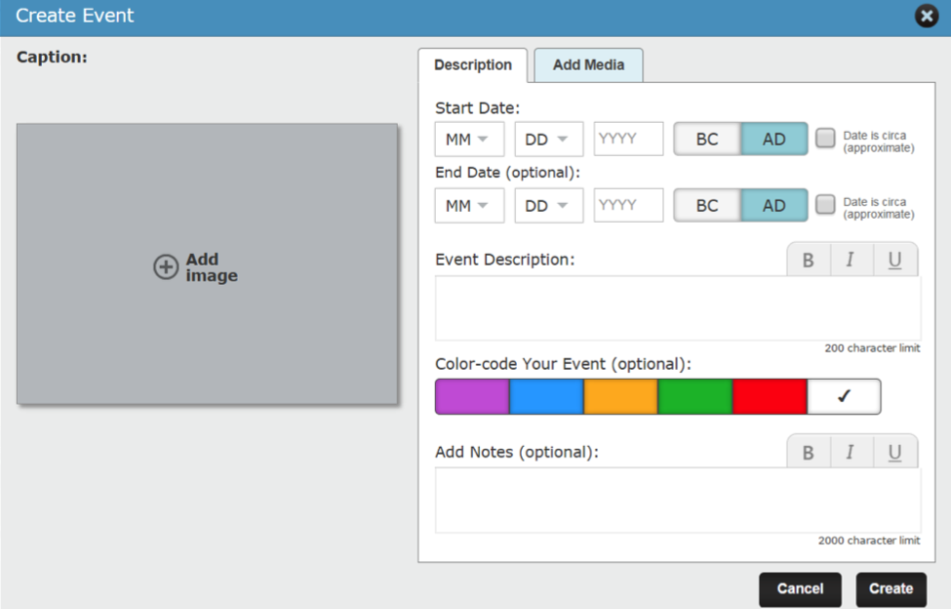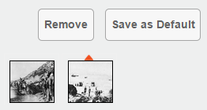
- To add an image to show on your timeline, click Add Image.
- To add more images or videos click Add Media.
You can search for World Book images and videos or upload your own images to the event by either uploading a new image (JPG and GIF files under 5 MB) or choosing an image you've previously uploaded to World Book Timelines from My Images.
- You can use one of your new images to show on your actual timeline by selecting the image and clicking Save as Default.
Don’t forget to click save when you’re done! 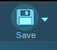
You can find your new World War I Timeline under MY TIMELINES.
TIPS:
Print: Print a timeline by first selecting Switch View to view the timeline in List View. Print the timeline by choosing the Print button.
Switch View: Select the Switch View option near the top right of the page to view your timeline in Print View.
Zoom in or out: View more events by either adjusting the zoom level by clicking or tapping on the plus or minus buttons on the zoom slider or by using the up, down, left, and right arrows.

