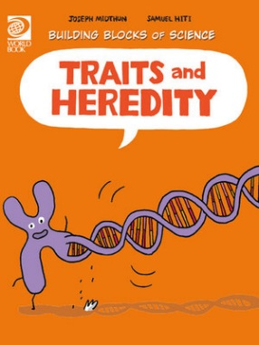
Traits and Heredity Activity Sheet
- True or False? You are made up of cells.
- What are cells?
________________________________________________________________________
- How do cells build a person or a plant?
________________________________________________________________________
- Give an example of a trait?
________________________________________________________________________
- What is heredity?
________________________________________________________________________
- Where do you get your traits from?
________________________________________________________________________
- Why do offspring often look like their parents?
________________________________________________________________________
- What tells the cell how to grow and develop into a living organism?
________________________________________________________________________
- True or false? We all have the same genes.
- How are genes inherited by offspring from parents?
________________________________________________________________________
- True or false? Your cells have half of your father’s gene pairs and half of your mother’s gene pairs.
- What makes each person different to everyone else?
________________________________________________________________________
- What did Gregor Mendel’s experiment with the pea plant help us understand about genes?
________________________________________________________________________
- What is a hybrid?
________________________________________________________________________
- What influences the development of traits?
________________________________________________________________________
- True or false? Your genes and surroundings help you adapt to your environment.

Answers:
- True.
- Cells are tiny organisms that work together to make up all living things.
- Through genes and DNA.
- Eye colour, hair colour, height or weight.
- Heredity is the passing on of biological characteristics from one generation to the next.
- Heredity, from your mother and father.
- Heredity. You inherit genes from your mother and father.
- Chromosomes.
- False.
- Through reproduction.
- True.
- Gene variation. Genes come in many varieties.
- Gregor Mendel’s experiment helps us understand that all of an organism’s traits are passed from one generation to the next.
- A hybrid is the offspring of parents of different breeds, varieties, or species.
- Interaction of that gene with other genes and partly on your environment (nature and nurture).
- True.

