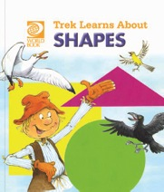
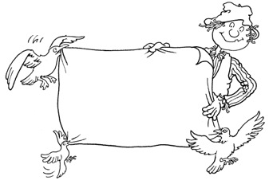
Trek’s Travels –

SHAPES

Talking about the square shape

1. How many sides does a square have? ___________________
2. Does it have straight or curved sides?
_________________________________________________________________
3. How many corners can you count on the square?
_________________________________________________________________
4. Can you see any squares in the room?
_________________________________________________________________
5. What other objects have a square shape?
_________________________________________________________________

Talking about the circle shape

1. Can you see any corners on the circle? __________________

2. Can you see any circles in the room?
_________________________________________________________________
3. What other objects have a circle shape?
_________________________________________________________________
Talking about the triangle shape

1. How many sides does a triangle have? __________________

2. Are the sides straight or curved?
_________________________________________________________________3. How many corners can you count on the triangle?
_________________________________________________________________4. Can you find any triangles in the room?
_________________________________________________________________5. What other objects have a triangle shape?
_________________________________________________________________6. Why is a triangle different from a square?
_________________________________________________________________

Talking about the rectangle shape

1. How many sides does a rectangle have? ________

2. Are the sides straight or curved?
_________________________________________________________________3. How many corners can you count on the rectangle?
_________________________________________________________________4. Can you find any rectangles in the room?
_________________________________________________________________5. What other objects have a rectangle shape?
_________________________________________________________________6. Why is a square different from a rectangle?
_________________________________________________________________
ACTIVITY –

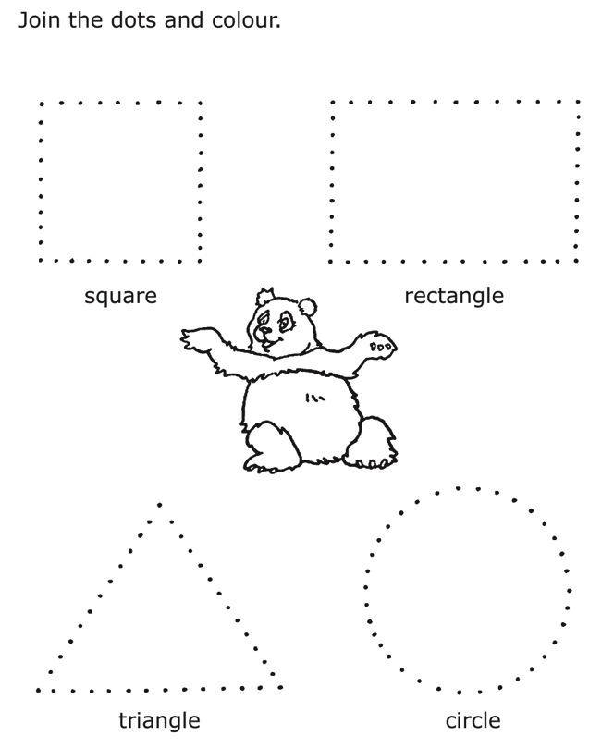

Aim: to recognise the four basic shapes and practice pencil control.

ACTIVITY –
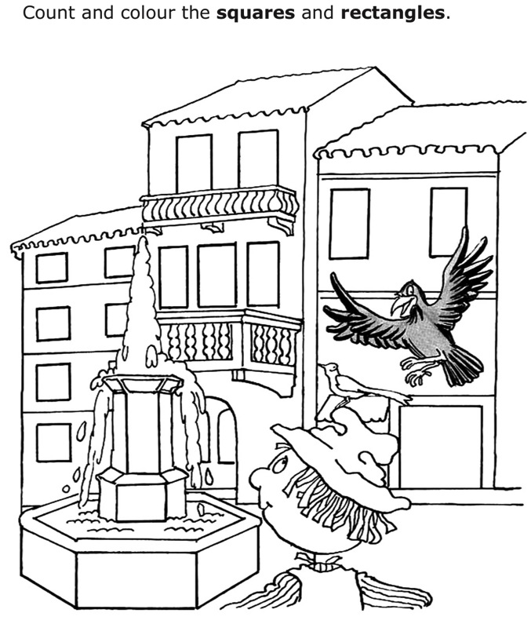

How many squares? _________________
How many rectangles? _______________

Aim: to identify shapes and practice counting.
Trek’s World Travels
Where in the world does Trek learn about shapes?
China

