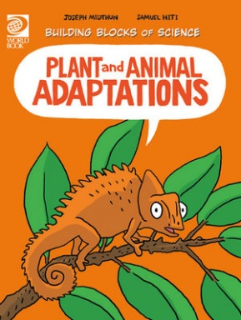
Plant and Animal Adaptations Activity Sheet
- What does an organism do when it does not get what it needs from its environment?
________________________________________________________________________
- What is adaptation?
________________________________________________________________________________________________________________________________________________
- How do adaptations develop and spread?
________________________________________________________________________
- Give an example of natural selection.
________________________________________________________________________
- True or False? Animals need to adapt to changing environments to survive.
- True or False? Scientists believe that plants developed from green algae that lived in freshwater a long time ago.
- Give an example of an adaptation most animals share.
________________________________________________________________________________________________________________________________________________
- Give an example of how plants and/or animals have adapted to protect themselves from predators?
________________________________________________________________________
- How have cactuses adapted to their environment?
________________________________________________________________________________________________________________________________________________
- How have aquatic plants adapted to the water?
________________________________________________________________________
- True or False? Feet are an adaptation for walking and running.
- What example is depicted on page 27 of how a plant has adapted to an environment that is low in nutrients.
________________________________________________________________________
- True or False? Animals and plants moving into a new environment do not change an ecosystem.
- True or False? Farming is an example of how humans have adapted and altered the environment.

ANSWERS:
- It adapts.
- Adaptation is a characteristic of an organism that makes it better able to survive and reproduce in its environment.
- Through the process of natural selection.
- The variation of traits in moths wing colour makes it less visible to predators. It is then more likely to reproduce and share their colour trait.
- True
- True
- Teeth and jaws are adaptations for bringing food into the body. They are adapted for the particular food an animal eats.
- The poison dart frog has bright skin colours to warn predators that it is poisonous.
Plants have thorns.
Animals use camouflage.
- Cactuses have roots that spread over large areas, they store water in their fleshy stems instead of leaves.
- Plants keep tiny air spaces within their stems and leaves. These help them to stand upright or stay afloat.
- True
- A Venus-fly trap.
- False
- True

