**  
Timelines – Ottoman Empire**

**Go to** [**www.worldbookonline.com**](http://www.worldbookonline.com) **and log in using your school’s log in details:**

|  |  |
| --- | --- |
| **Log-in ID:** |  |
| **Password:** |  |

**Click on Advanced **

**Type in *Ottoman Empire* in Search box**



**Click the article titled *Ottoman Empire***

**Read the article and answer the questions below.**

1. **When did the Ottoman Empire begin?**

___________________________________________________________________________

1. **Osman’s tribes captured the city of Bursa in which year?**

___________________________________________________________________________

1. **The Byzantine Empire had occupied parts of Asia Minor and south-eastern Europe for almost 1,000 years. When did the empire end and why?**

___________________________________________________________________________

1. **By mid 1500s (c. 1550), the Ottomans ruled which areas?**

___________________________________________________________________________

1. **When was Syria conquered?**

___________________________________________________________________________

1. **When was Egypt conquered?**

___________________________________________________________________________

1. **When was the Ottoman Empire at its peak with the conquering of which regions?**

___________________________________________________________________________

1. **Who fought in the Battle of Lepanto in 1571 and what happened to the Ottoman fleet?**

___________________________________________________________________________

1. **What happened in 1683?**

___________________________________________________________________________

1. **When did the Ottoman Empire start to decline and why?**

___________________________________________________________________________

1. **A constitution, which guaranteed an elected parliamentary government was briefly adopted under Abdulhamit in which year?**

___________________________________________________________________________

1. **When was it reinstated and why?**

___________________________________________________________________________

1. **At the start of World War I in 1914, which regions did the Ottoman Empire consist of?**

___________________________________________________________________________

1. **The Ottoman Empire, an ally with Germany, was defeated in World War I and lost much of its territory. What year did World War I end?**

___________________________________________________________________________

1. **The Ottoman Empire came to an end in what year?**

___________________________________________________________________________

1. **Following World War I, the Ottoman Empire was occupied by Allied nations. In what year did a nationalist movement led by Kemal Ataturk, effectively end the occupation of Turkey?**

___________________________________________________________________________

1. **When was the Republic of Turkey born?**

___________________________________________________________________________

1. **Create a timeline from your answers.**

Scroll to bottom of page and select TIMELINES.

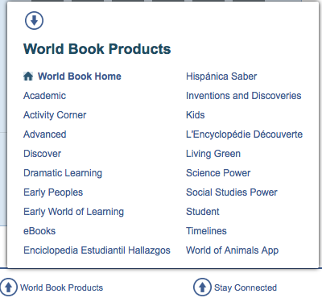

* Log in to your My Research Account using your personalised log in details – this is how you save your Timeline



* Click “Create a Timeline” to create a timeline.



* Click “Create an Event” to enter in an event



* Provide the date and summary of the event that happened during that time. You can add images and additional facts about the event too.

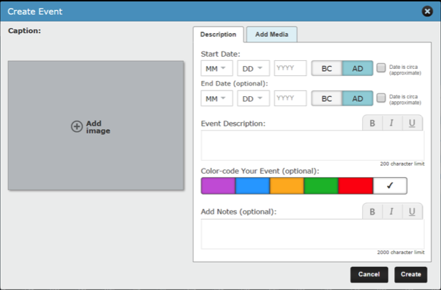

To add images to do with Ottoman Empire to your event:

Type “Ottoman Empire” in Search Box. Select image, click “Add”, and then click “Save”. You can add your own images too by clicking “Upload” and saving your own images to the Timeline.

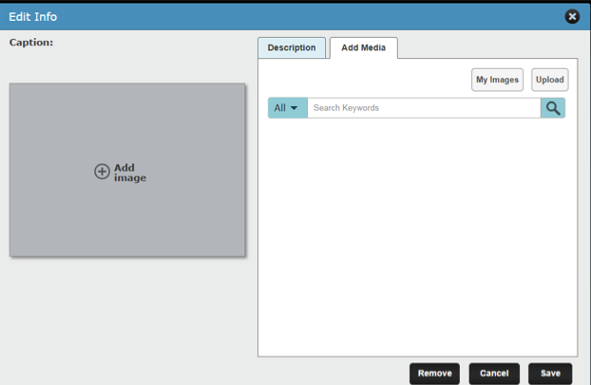

* Don’t forget to save your Timeline!



**Ottoman Empire Scavenger Hunt**

ANSWERS:

1. c. 1300
2. 1326
3. The Byzantine Empire ended in 1453 when the Ottomans conquered the Byzantine capital of Constantinople.
4. Asia Minor, the Balkans, and part of Northern Africa and present-day Iran, Saudi Arabia, and Syria.
5. 1516
6. 1517
7. Under Sultan Suleyman I, who ruled from 1520 – 1566. Conquering Hungary, northern Africa, and territory on the east coast of the Red Sea down to what is now Yemen.
8. Naval forces from Spain, Venice, and Papal States of Italy fought the Ottoman fleet. The Ottoman fleet was almost destroyed.
9. Austrian and Polish troops turned back an Ottoman attack on Vienna, Austria, subsequently ending the Ottoman Empire’s territorial expansion.
10. After 1700, when it was faced with the emerging powers of Europe.
11. 1867
12. A group of Ottoman military officers called the Young Turks forced the reinstating of the constitution in 1908.
13. Asia Minor, parts of south-western Asia, and part of the Balkans.
14. 1918
15. 1922
16. 1922
17. 1923
18. Timeline.



