Life Cycle Scavenger Hunt – Kids and Student edition
Every living thing on the planet lives through a life cycle. Every plant and animal is dependent on each other and the environment to survive. Read about Life Cycles on the World Book Web and see if you can find the answers to the following questions!
- Go to www.worldbookonline.com
- Click on Kids
- Search for Life Cycle in the search box and answer the below questions:
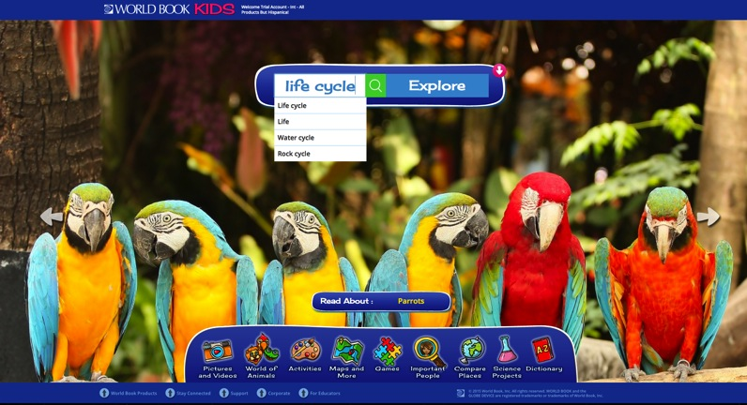
- What is the life cycle?
- Before a new animal is born, where does it develop?
Click on the picture Life Cycle of Ants
- What are the four life stages of an ant?
Now, scroll down to the toolbar at bottom of the page, click on World Book Products and find the word “Student”. Click on it.
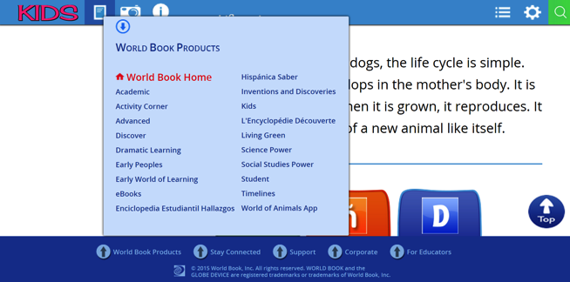
Now search for Salmon in the search box. When all the search items come up, click on the word “Salmon”
Answer the following questions:
- What does ‘spawn’ mean?
Now scroll down to find the section titled: The life of a Salmon.
- How long does it take for the salmon eggs to hatch?
- What kind of water do salmon hatch in?
- A small percentage of adult salmon spend part of their life in the ocean. Is this true or false?
- Most salmon return for spawning to the same stream or lake in which they hatched. How do scientists think salmon know how to find their way back?
- What happens to the body of a salmon when they travel upstream to spawn?
- Why do many salmon not complete the spawning journey?
Did You Know?
- During spawning, the female salmon lays a total of 2,000 to 17,000 eggs.
- Metamorphosis is the term given to describe the extreme changes in form and appearance that occur in lower animals (insects and bugs) between the growing phase of life and the mature adult phase.
Learn More!
- To see the life cycle of a beetle, click here.
http://www.worldbookonline.com/student/media?id=lr001475
- See a salmon swimming upstream to spawn
http://www.worldbookonline.com/student/media?id=vd000150
- Watch a video on the life cycle of a frog
http://www.worldbookonline.com/student/media?id=am000106
Answer Key
- A life cycle is a set of steps, or stages, that living things go through as they grow, change, and produce other living things.
- A New animal develops in the mother's body.
- (1) Egg, (2) Larva, (3) Pupa, and (4) Adult.
- Reproduce.
- Salmon eggs hatch after two to four months.
- Salmon hatch in fresh water.
- True.
- Many scientists think salmon navigate in the sea by somehow sensing the magnetic field of the earth, the currents of the ocean, and the position of the sun. After reaching the coast, the salmon apparently remember the odour of their "home" stream and follow this scent.
- As the salmon travel upstream, their shape and colour change. For example, all male salmon develop a hooked snout. Male pink salmon grow a large hump on their back. Chum salmon of both sexes develop purple streaks on their sides, and sockeye salmon turn bright red.
- Many salmon do not complete the spawning journey. Commercial fishing crews and sports enthusiasts catch large numbers of the fish. Some salmon are killed by pollutants dumped into the rivers by industries.

