**  
TIMELINE Julius Caesar – Scavenger Hunt  
Go to** [**www.worldbookonline.com**](http://www.worldbookonline.com) **and log in using your school’s log in details:**

|  |  |
| --- | --- |
| **Log-in ID:** |  |
| **Password:** |  |

**Click on Advanced **

**Type in *Julius Caesar* in Search box**



**Look at the article on Julius Caesar and answer the questions below.**

1. Gaius Julius Caesar was born in Rome into a famous patrician family. When was he born?

___________________________________________________________________________

1. At the age of 17, Caesar married Cornelia, the daughter of Lucius Cornelius Cinna, an ally of Marius. What year was this?

___________________________________________________________________________

1. After time in Greece studying philosophy and oratory, Caesar was made a pontiff (Roman priest) and returned to Rome. What year did he return to Rome?

___________________________________________________________________________

1. Caesar was then elected a quaestor (financial official). In what year?

___________________________________________________________________________

1. In his elected role of aedile, Caesar put on lavish public games and displayed the Trophies of Marius on the Capitoline Hill. Which year was Caesar elected to the office of aedile?

___________________________________________________________________________

1. *Fill in the blanks.* Caesar continued to be elected to more roles. He was elected to the second-highest position in the Roman Republic, the ___________, in ______ B.C?
2. Caesar allied himself with Marcus Licinius Crassus and Gnaeus Pompey, the alliance is called the First Triumvirate. In what year was the alliance formed?

___________________________________________________________________________

1. *Fill in the blanks.* Through the use of violence and bribery, Caesar was elected a ­­_______, the highest political office in Rome, in _____.
2. Caesar recognised that he needed military victories to gain further fame. How long did his campaigns in Gaul run?

___________________________________________________________________________

1. Whilst in Gaul, the First Triumvirate alliance began to deteriorate. Crassus was killed and Pompey became alarmed by Caesar’s success. Caesar’s enemies start plotting against him by preventing him from standing for consul while absent from Rome. When did this happen?

___________________________________________________________________________

1. A civil war broke out in which year?

___________________________________________________________________________

1. Caesar defeated Pompey’s troops and in 60 days, he was master of Italy and had himself appointed dictator and consul. However, Caesar pursued Pompey. What date did Caesar defeat Pompey’s forces at Pharsalus, Greece?

___________________________________________________________________________

1. *Fill in the blanks.* Pompey escaped to _______ but was killed as he stepped off the boat on the orders of ________. There he met _______, with whom he had a love affair and fathered a son named _______.
2. Caesar spent time in Syria and Asia Minor defeating kings loyal to Pompey. Match the defeat with the right date:

|  |  |
| --- | --- |
| 1. Defeated King Pharnaces II of Pontus at Zela (Turkey) | 45 B.C. |
| 1. Defeated Pompey’s followers at the Battle of Thapsus in Africa | 47 B.C. |
| 1. Defeated Pompey’s two sons in Munda Spain | 46 B.C. |

1. Following the defeat of his enemies, Caesar was the undisputed master of the Roman world. By what year was Caesar dictator for life and given honours normally given to gods?

___________________________________________________________________________

1. Suspicions that Caesar planned to make himself king, led to a plot by a group of senators to kill Caesar. On what date was the plot acted on.

___________________________________________________________________________

1. *Add missing events to the Julius Caesar Timeline.*

Look at the Julius Caesar Timeline in *Timelines*. Can you see any events that are missing? Add them to the Julius Caesar Timeline.

Scroll to bottom of page and click on Timelines

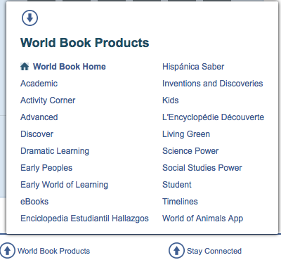

Log in to your My Research Account using your personalised log in details – this is how you save edits to the Timeline



Then search for *Julius Caesar* in Timelines



To add an event click “Create Event” 

Enter in the date and event details.

Choose a colour and colour-code the event to show which events you have created.

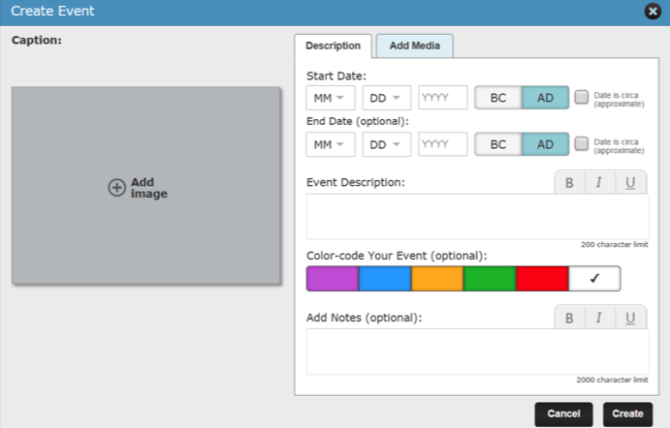

Don’t forget to click save when you’re done! 

You can find your new Julius Caesar Timeline under My Timelines. 

**Julius Caesar Scavenger Hunt**

**Answers:**

1. 100 B.C.
2. 83 B.C.*
3. 73 B.C.*
4. 68 B.C. *
5. 60’s B.C.
6. Praetor (judicial official), 62 B.C.
7. 60 B.C.
8. Consul. 59 B.C.*
9. 58 B.C – 51 B.C.
10. 52 B.C.*
11. 49 B.C.
12. 48 B.C.
13. Egypt. Ptolemy XIII. Cleopatra. Caesarion.
14. a) 47 B.C. b) 46 B.C. c) 45 B.C
15. 44 B.C.
16. 15 March 44 B.C.
17. Timeline.

* Added events



