Habitats Scavenger Hunt – NEW World Book Kids
Every living thing on Earth has a habitat. What do you know about habitats? Learn more about habitats on the World Book Web and then find the answers to the following questions!
Find It!
- What is a habitat?
______________________________________________________________
- What does a habitat have to have for a living thing to survive?
______________________________________________________________
- Match the type of animal/plant to their habitat.
Polar Bear |  | Freshwater pond
Cactus |  | Arctic ocean
Water Lily |  | Rainforest
Parrot |  | Desert
- Many different kinds of plants and animals can share a habitat. True or false?
______________________________________________________________
- Go to World of Animals on the Homepage and compare the animals and name their habitats.
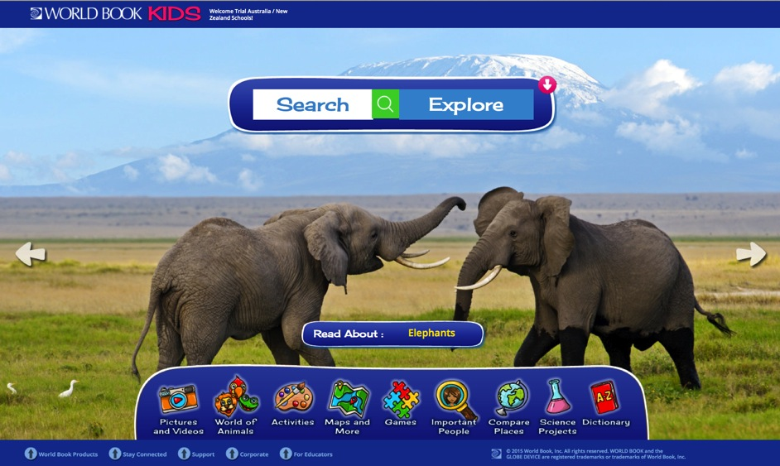
- Shark and Crocodile
______________________________________________________________
- Python snake and Koala
______________________________________________________________
- Polar Bear and Panda
______________________________________________________________
- Whale and Hippopotamus
______________________________________________________________
- Eagle and Puffin
______________________________________________________________
- Cheetah and Bear
______________________________________________________________
- Camel and Llama
______________________________________________________________
- Tiger and Lion
______________________________________________________________
- Squirrel and Rabbit
______________________________________________________________
- Mole and Meerkat
______________________________________________________________
- Pick your own!
______________________________________________________________
Did You Know?
- Animals and plants throughout the world are endangered because their habitats have been destroyed.
- Tropical rainforests are the native habitat to more species of plants and animals than any other area on Earth.
- Rainforests are being destroyed faster than any other wild habitat.

Learn More!
- Click here to learn about endangered species and their loss of habitat
  - http://www.worldbookonline.com/kids/home#article/ar830695
- Watch the video called Animals of temperate forests to see animals that live in temperate forests – habitat to bears, chipmunks, deer, raccoons and more.
  - http://www.worldbookonline.com/kids/home#article/ar830499
- Click here to read about Steve Irwin, wildlife expert, who captured crocodiles and moved them to safer habitats.
- http://www.worldbookonline.com/kids/home#article/ar832284
Answer Key
- A habitat is the kind of place where a plant, animal, or other organism lives in the wild.
- A habitat has everything that a living thing needs to survive, such as the right climate and source of food.
- Polar Bear – Arctic Ocean
Cactus – Desert
Water lily – Freshwater pond
Parrot – Desert
- True.
- a) Shark – ocean | Crocodile – coastal waters and rivers
b) Python – Forests, grasslands, marshes, always near water | Koala – Eucalyptus forests
c) Polar Bear – sea ice and nearby land | Panda – bamboo forests
d) Whale – oceans | Hippopotamus – lakes, rivers, and streams near grasslands
e) Eagle – coastal areas, forests, mountainous areas | Puffins – coastal waters of the Atlantic and Pacific Oceans
f) Cheetah – grasslands | Bear – forests and open areas, usually near water
g) Camel – deserts | Llama – grasslands and mountains
h) Tiger – Forests, marshes, grasslands | Lion – grasslands and forests
i) Squirrel – forests | Rabbit – forests and grasslands
j) Mole—grasslands and forests | Meerkat – deserts

