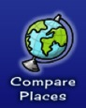

www.worldbookonline.com

COMPARE PLACES SCAVENGER HUNT – WORLD BOOK KIDS
Compare Australia with Indonesia

Click on Kids

COMPARE PLACES:
This is where you can compare continents, countries, states, or compare everything with the click of a button.

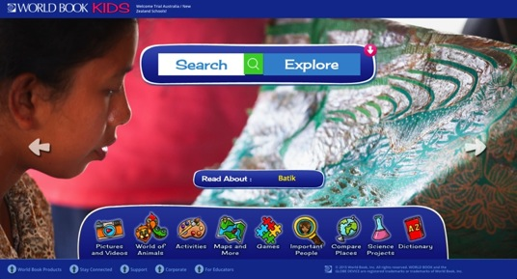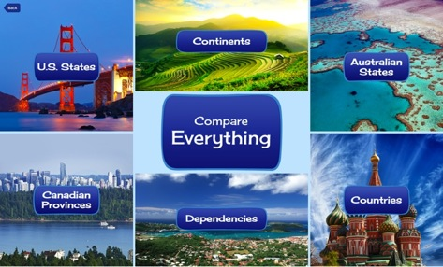

Let’s compare Australia with Indonesia –
» Click on button.
» Click on button to compare Australia with Indonesia.

1. To choose Australia, click on the Australian flag  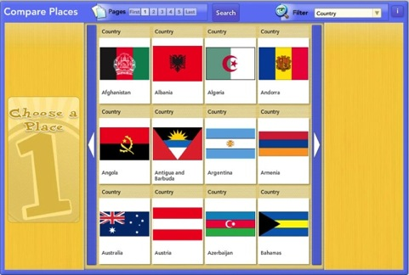 | 2. Click  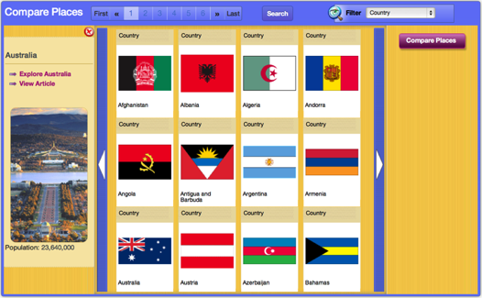
3. Search for Indonesia using the arrow  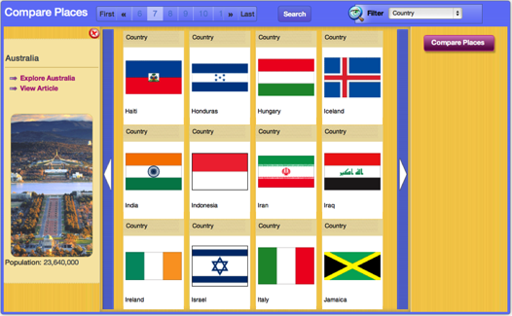 | 4. To choose Indonesia, click on the  Indonesian flag.  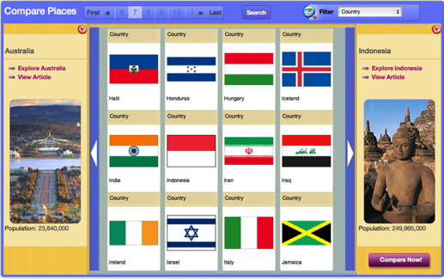
5. Click to compare both countries.
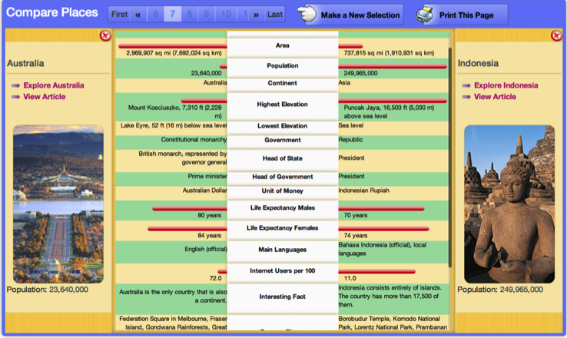
See the difference between Australia and Indonesia.

Find the answers to the questions using the slide bar to scroll down the list.
QUESTIONS:
Which country has the largest population? _____________________________________________________
Indonesia is found on which continent? _______________________________________________________
The capital of Australia is ____________________________________________________________________
The capital of the Indonesia is ________________________________________________________________
The highest mountain in Australia is ___________________________________________________________
The highest mountain in Indonesia is __________________________________________________________
Name one famous place in Australia ___________________________________________________________
Name one famous place in Indonesia___________________________________________________________

6. Click to view facts about Australia.

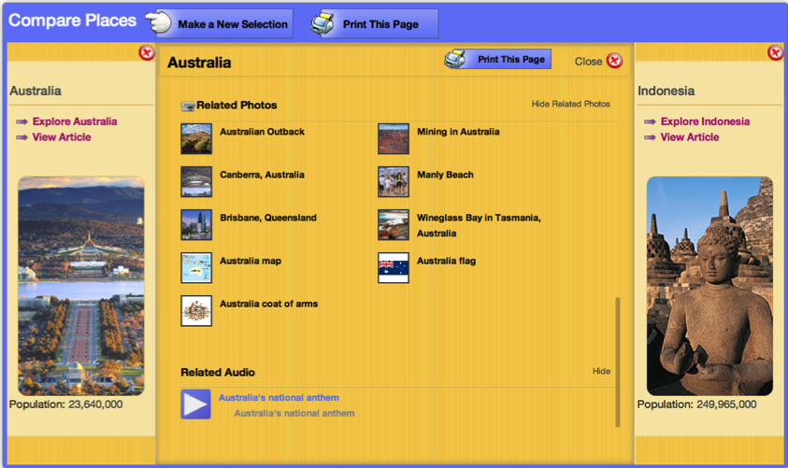

Using the slide bar, scroll down to Australia’s national anthem.
Click the arrow to play the national anthem.
7. Click to view facts about Indonesia.

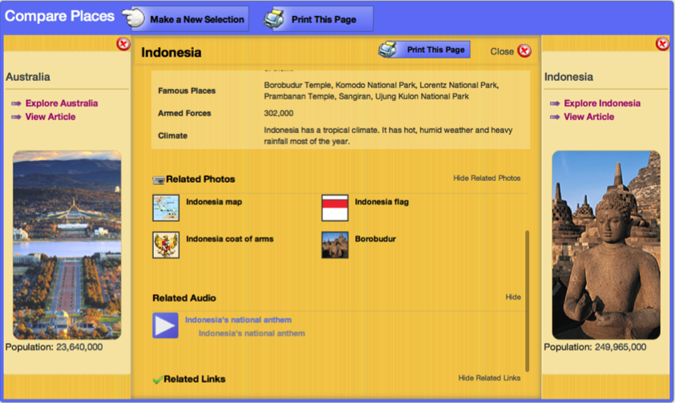

Using the slide bar, scroll down to Indonesia’s national anthem.

Click the arrow to play the national anthem.

- Colour the flag of Australia
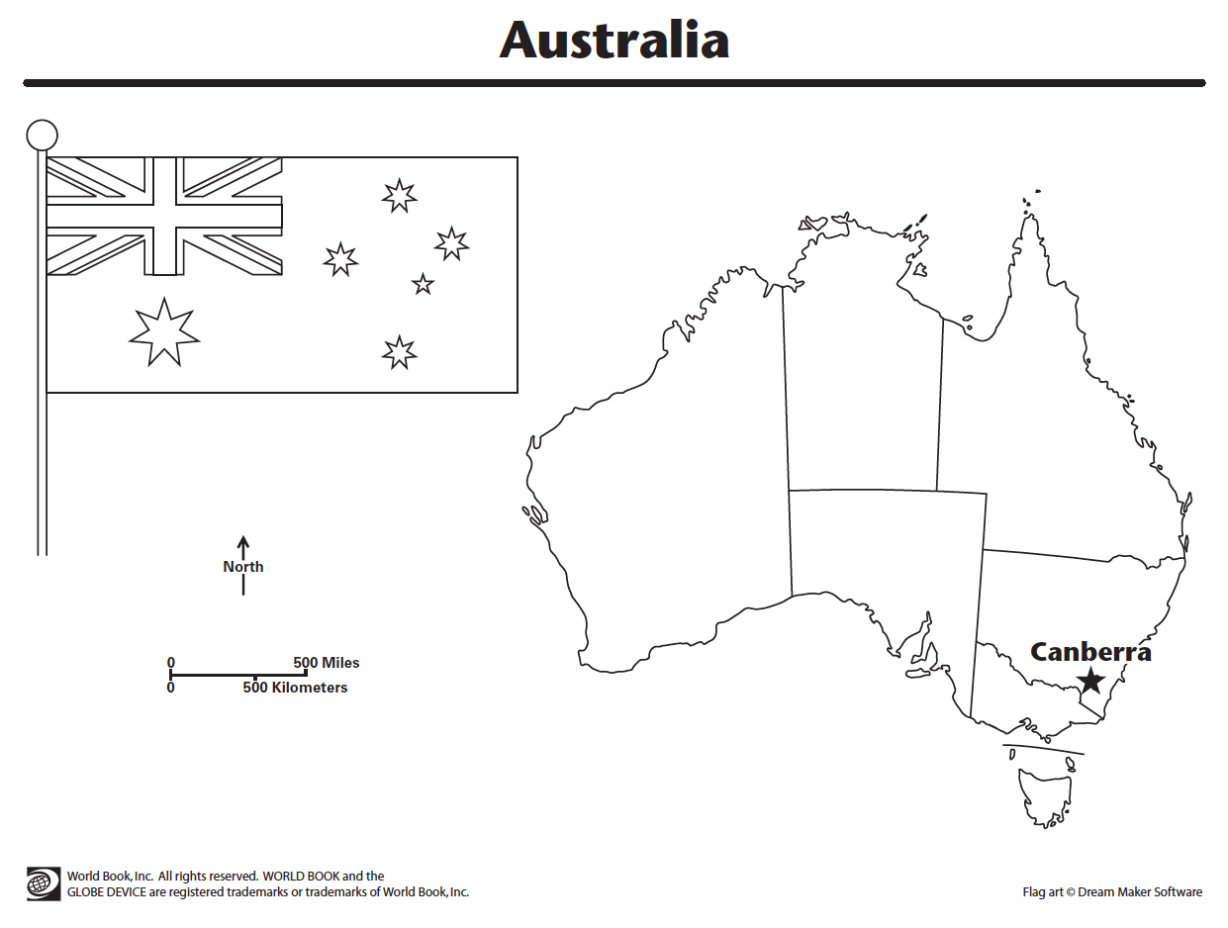
- Colour the flag of Indonesia.
