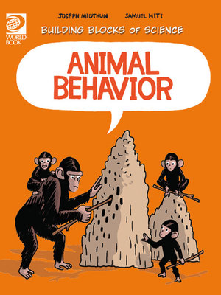

Animal Behaviour Activity Sheet
- What is an “instinct”?
_________________________________________________________________________
- What are learned behaviours?
_________________________________________________________________________
- What are instincts and learned behaviours used for?
_________________________________________________________________________
- What is the difference between an instinct and a learned behaviour?
__________________________________________________________________________________________________________________________________________________
- What is the difference between an instinct and reflexes?
__________________________________________________________________________________________________________________________________________________
- Watch the video on page 8. Why do spiders instinctively build a web?
_________________________________________________________________________
- How do animals learn?
_________________________________________________________________________
- What type of behaviours do chimpanzees learn?
__________________________________________________________________________________________________________________________________________________
- Name some animals that learn to communicate with each other.
_________________________________________________________________________
- Why do some animals live in groups?
___________________________________________________________________________________________________________________________________________________________________________________________________________________________
- Why do animals have instincts to seek shelter?
_________________________________________________________________________
- How do outside changes trigger instincts?
_________________________________________________________________________
- What is migration?
_________________________________________________________________________
- Watch the video on page 23. Where do wildebeests migrate to?
_________________________________________________________________________
- Why do animals hibernate?
_________________________________________________________________________

ANSWERS:
- Instincts are inherited knowledge that helps an animal to survive on its own.
- Learned behaviours are new behaviours learned by animals as they grow.
- Instincts and learned behaviours are used to survive.
- Instinctive behaviours are not learned but are decided by the genetic makeup of an organism.
- A reflex involves some stimulus that causes a response. Such as, shivering when cold.
- Web building spiders build webs to trap insects for food. If the spider doesn’t build a web to trap its food, it will starve.
- Learned behaviour comes from experience. It is also taught to young animals by older animals.
- Chimpanzees learn how to use a stick to reach termites and what sounds mean danger.
- Dolphins, birds, insects (ants, bees and termites), humans.
- - Help raise and watch over young
- Learn how to play to defend themselves
- Help find food and recognise which foods are safe to eat
- Protection from predators
- Hunt in groups and catch larger prey.
- Survival. The behaviour of building a home provides protection from predators and a place to raise young.
- Outside changes trigger animal instincts which tell them to migrate to find food, create offspring, or avoid harsh weather.
- Migration is when an animal travels to a new area that offers better living conditions.
- Wildebeests migrate to areas with more rain.
- Animals hibernate to survive harsh conditions. For example, bears hibernate during winter when food is hard to find. Some frogs hibernate to avoid dry conditions or extreme cold.

