World Book Advanced for iPads and Tablets: My Research
World Book Advanced My Research feature gives students individual accounts to save their research.
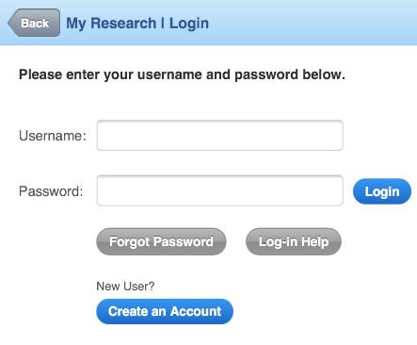  (1) Go to World Book Advanced  > Tap on My Research. | 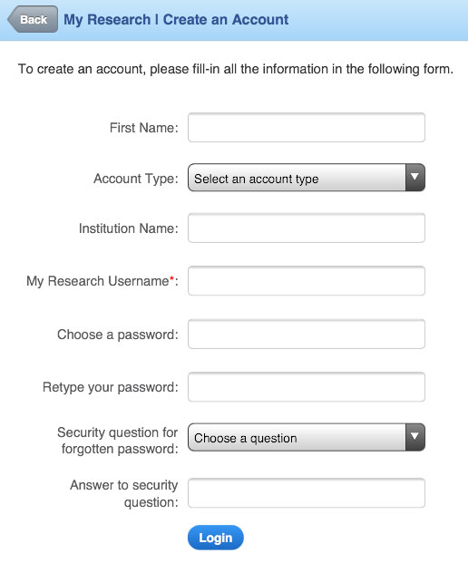  (2)  > Either log-in or tap on Create an Account to create your own account.  > Fill in all the information in the form.  > Tap Submit
Hint: Using your email address as your username will give you the option to have your password emailed to you if you have forgotten it. You also have the option to provide a username that is 6-10 characters long.
(3) > Tap on the arrow to expand each section.
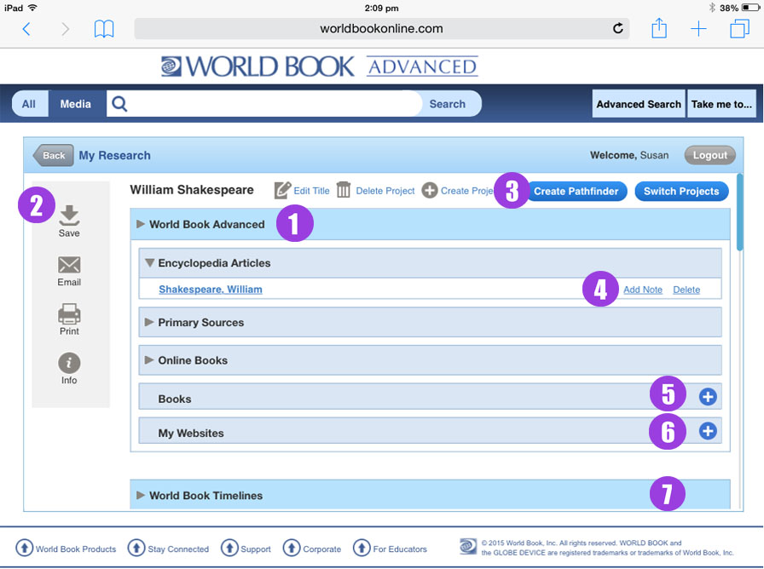
- World Book articles, images, citations, online books, primary source documents and other research results can be saved to a user’s My Research page.
- The Tools box on the left of the page includes options to Save, Email, and Print content. Click on Info to access the Help Screen.
- Create different folders within your My Research account to save content by topic or project.
Tap on Create Pathfinder to share your research project.
Tap on the Switch Projects button to select folders in the drop-down menu.
- You can delete entries, add notes to each content piece – a reminder, a detail to follow up on later, or other information to save for later reference.
- You can enter bibliographic information about books you’ve found in your research.
- You can add Websites for sites you’ve found in your research.
- You can save your Timelines to your My Research account.
Content saved in Advanced from the desktop version is also accessible through Advanced iPad or tablet “My Research”.

