SUGGESTED WORDING FOR YOUR NEWSLETTER
PROMOTING eBOOKS TO YOUR STUDENTS

FOR SCHOOLS: (NOTE: COPY and PASTE into your school newsletter. Remember to include the login ID and password after steps 2 and 3. PLEASE DO NOT POST THIS INFORMATION ON YOUR WEBSITE.)

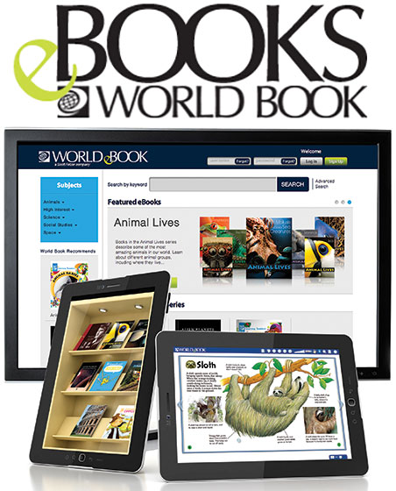

Good news! Our library now subscribes to the World Book eBook Series with access to hundreds of World Book publications as well as classic Open Access Books. Our World Book eBook subscription allows us to give you and your family access to all the eBook titles at home 24/7, using your computer or mobile device on a 3 week loan cycle.

To access the World Book eBook titles, follow these simple steps:
- Go to www.worldbookonline.com
- Enter Username <INSERT YOUR USER NAME HERE>
- Enter Password <INSERT YOUR PASSWORD HERE>
- Save your user name and password for faster login – simply tick the box labelled “Remember my ID and password”. The next time you visit World Book the login prompt will already contain your username and password.
- Click on the eBook icon. Bookmark the page or add to favourites for easy access to World Book eBooks in the future.

