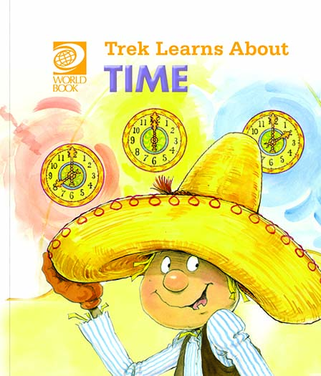
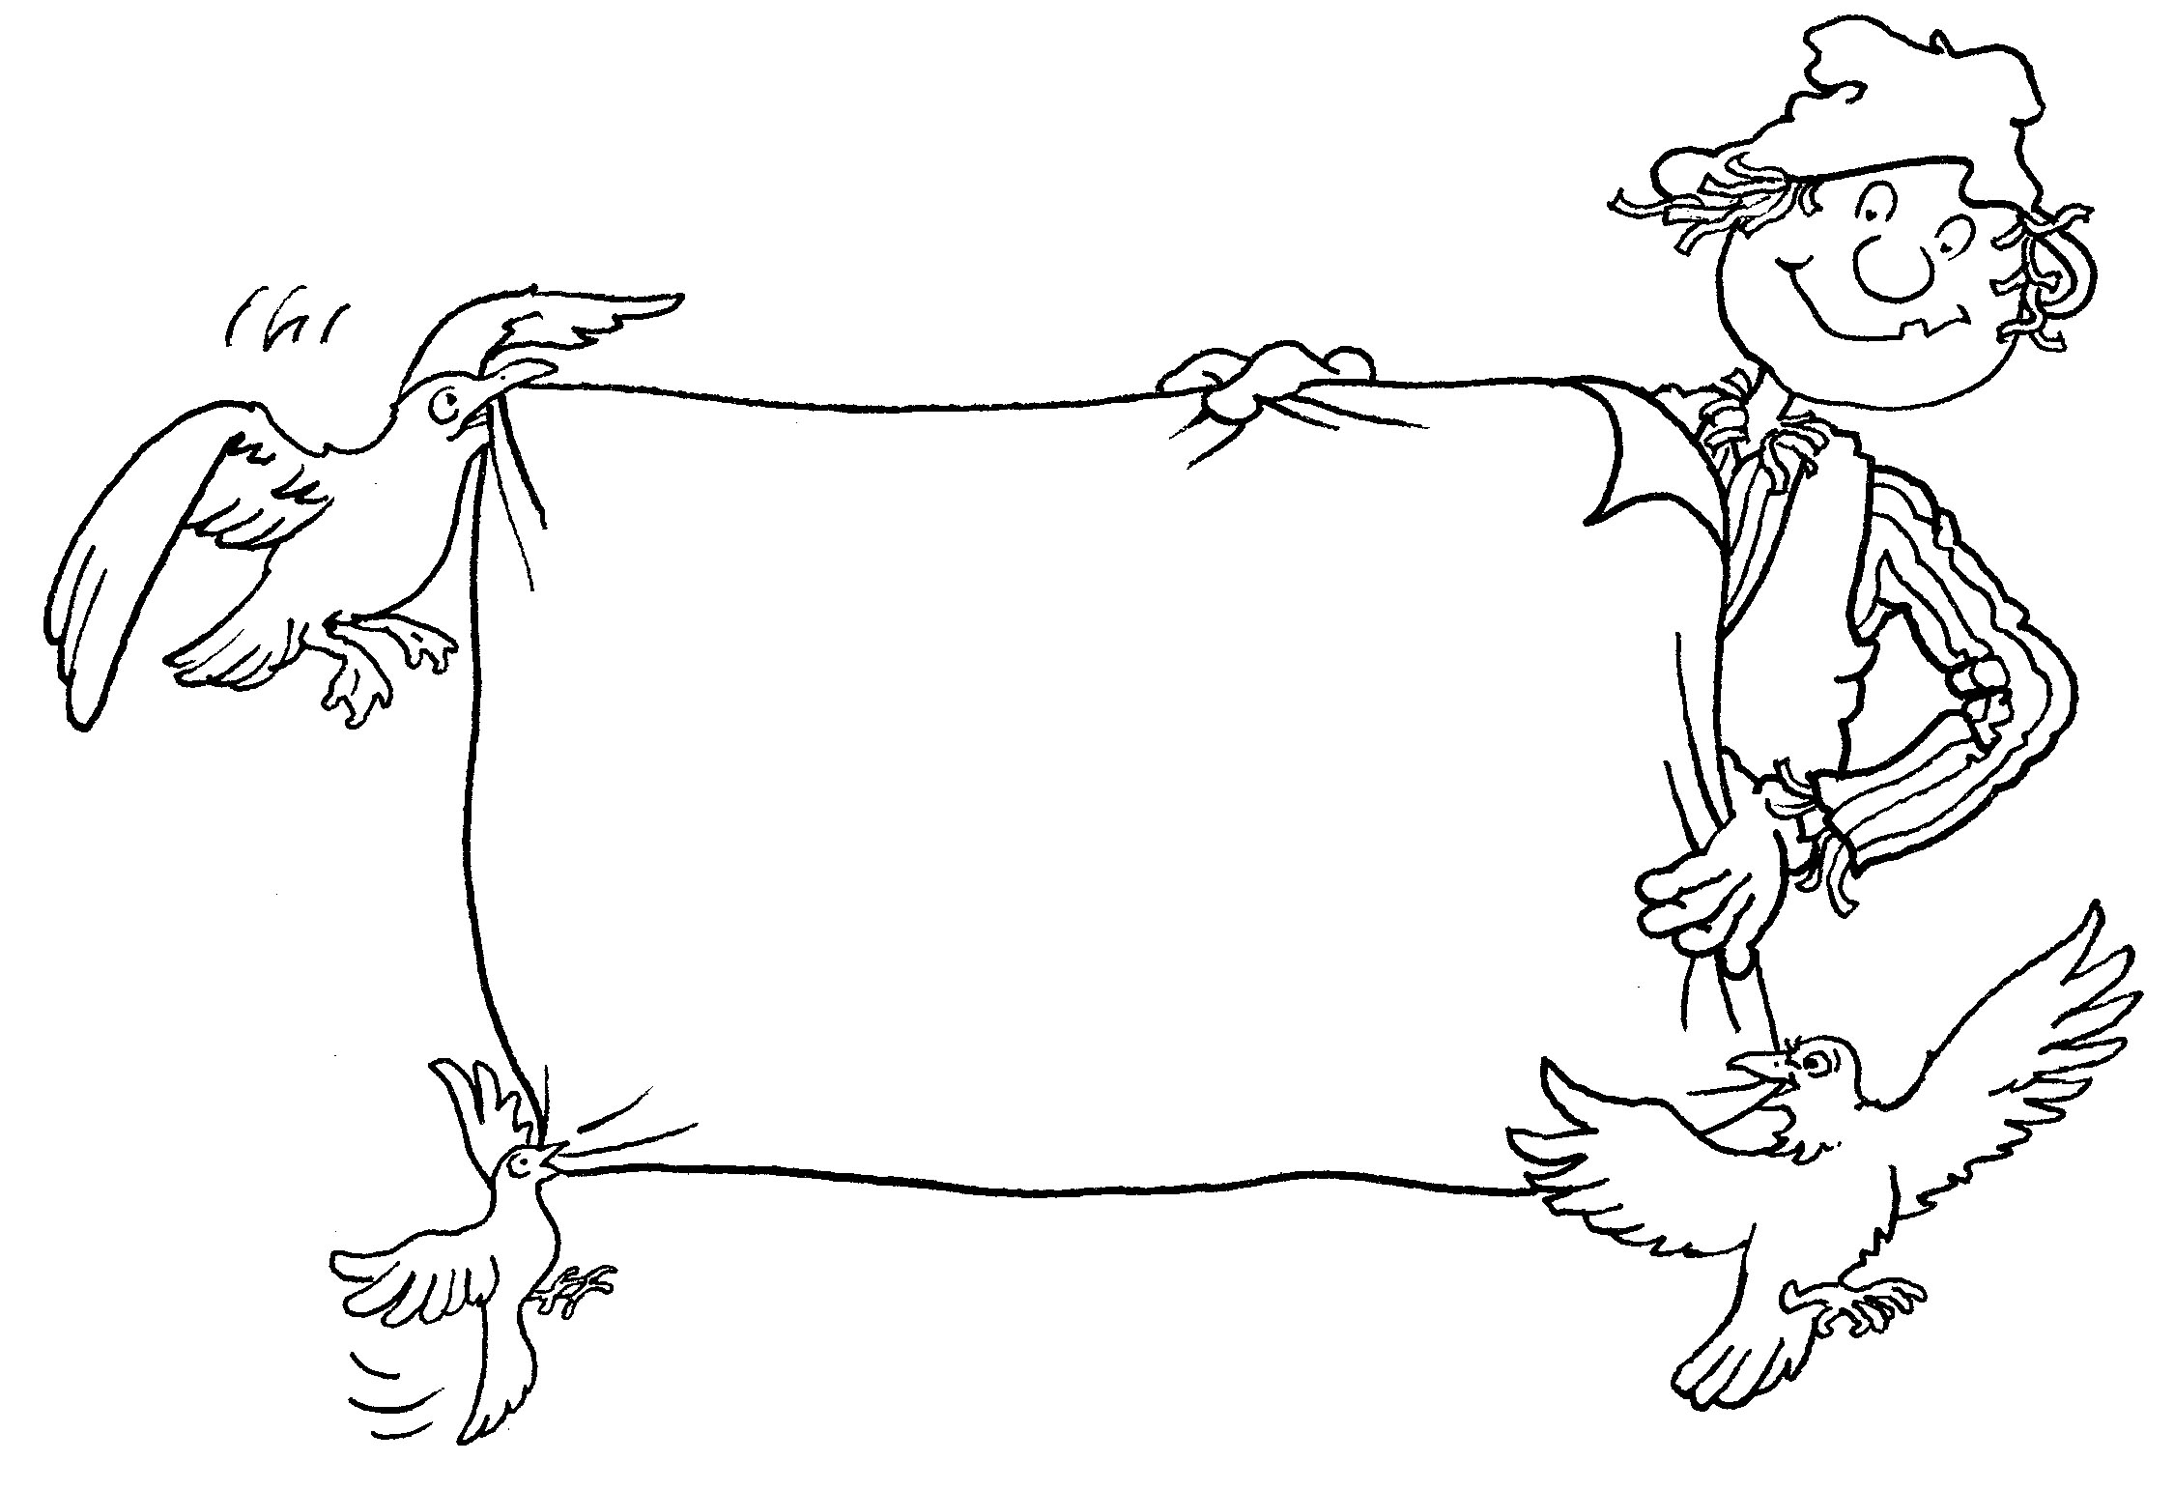
Trek’s Travels –

TIME

Time to get up
1. What time did Wagtail, Crow and Seagull get up?
_________________________________________________________________
2. What do the birds do when they get up?
_________________________________________________________________
3. Are they hungry when they get up?
_________________________________________________________________
4. What do you do when you get up? Do you wash, get dressed and eat breakfast?
_________________________________________________________________
5. Is the sun shining when you get up?
_________________________________________________________________6. What time do you get up?
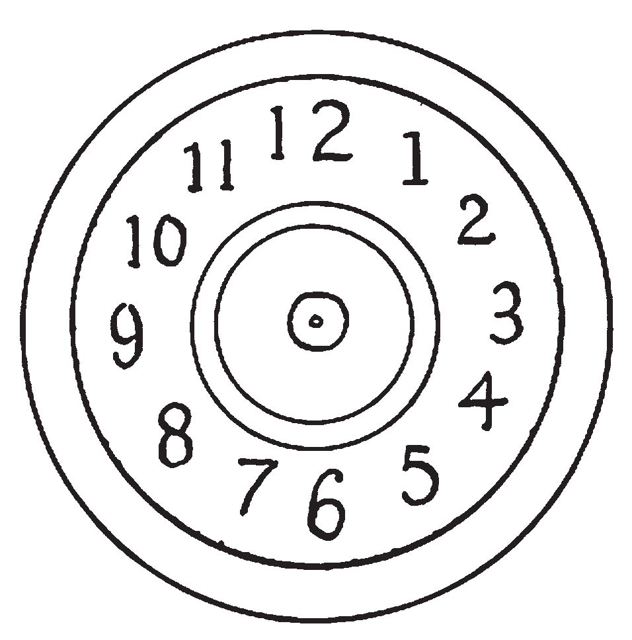____________________________

Time for lunch
1. What time did Trek get up?
_________________________________________________________________
2. Where do the hands of the clock point when it is midday?
3. Is the morning before or after midday?
_________________________________________________________________
4. Is the afternoon before or after midday?
_________________________________________________________________5. What did Trek and the birds do after lunch?
_________________________________________________________________6. What time did Trek wake up after his afternoon nap?
_________________________________________________________________
Time for supper
1. What time did Trek and the birds have their supper?
_________________________________________________________________
2. Do you eat a meal in the evening?
_________________________________________________________________
3. What time did Trek and his friends go to sleep?
_________________________________________________________________
4. What time do you go to bed?
_________________________________________________________________
5. Is it dark when you go to bed?
_________________________________________________________________
ACTIVITY –

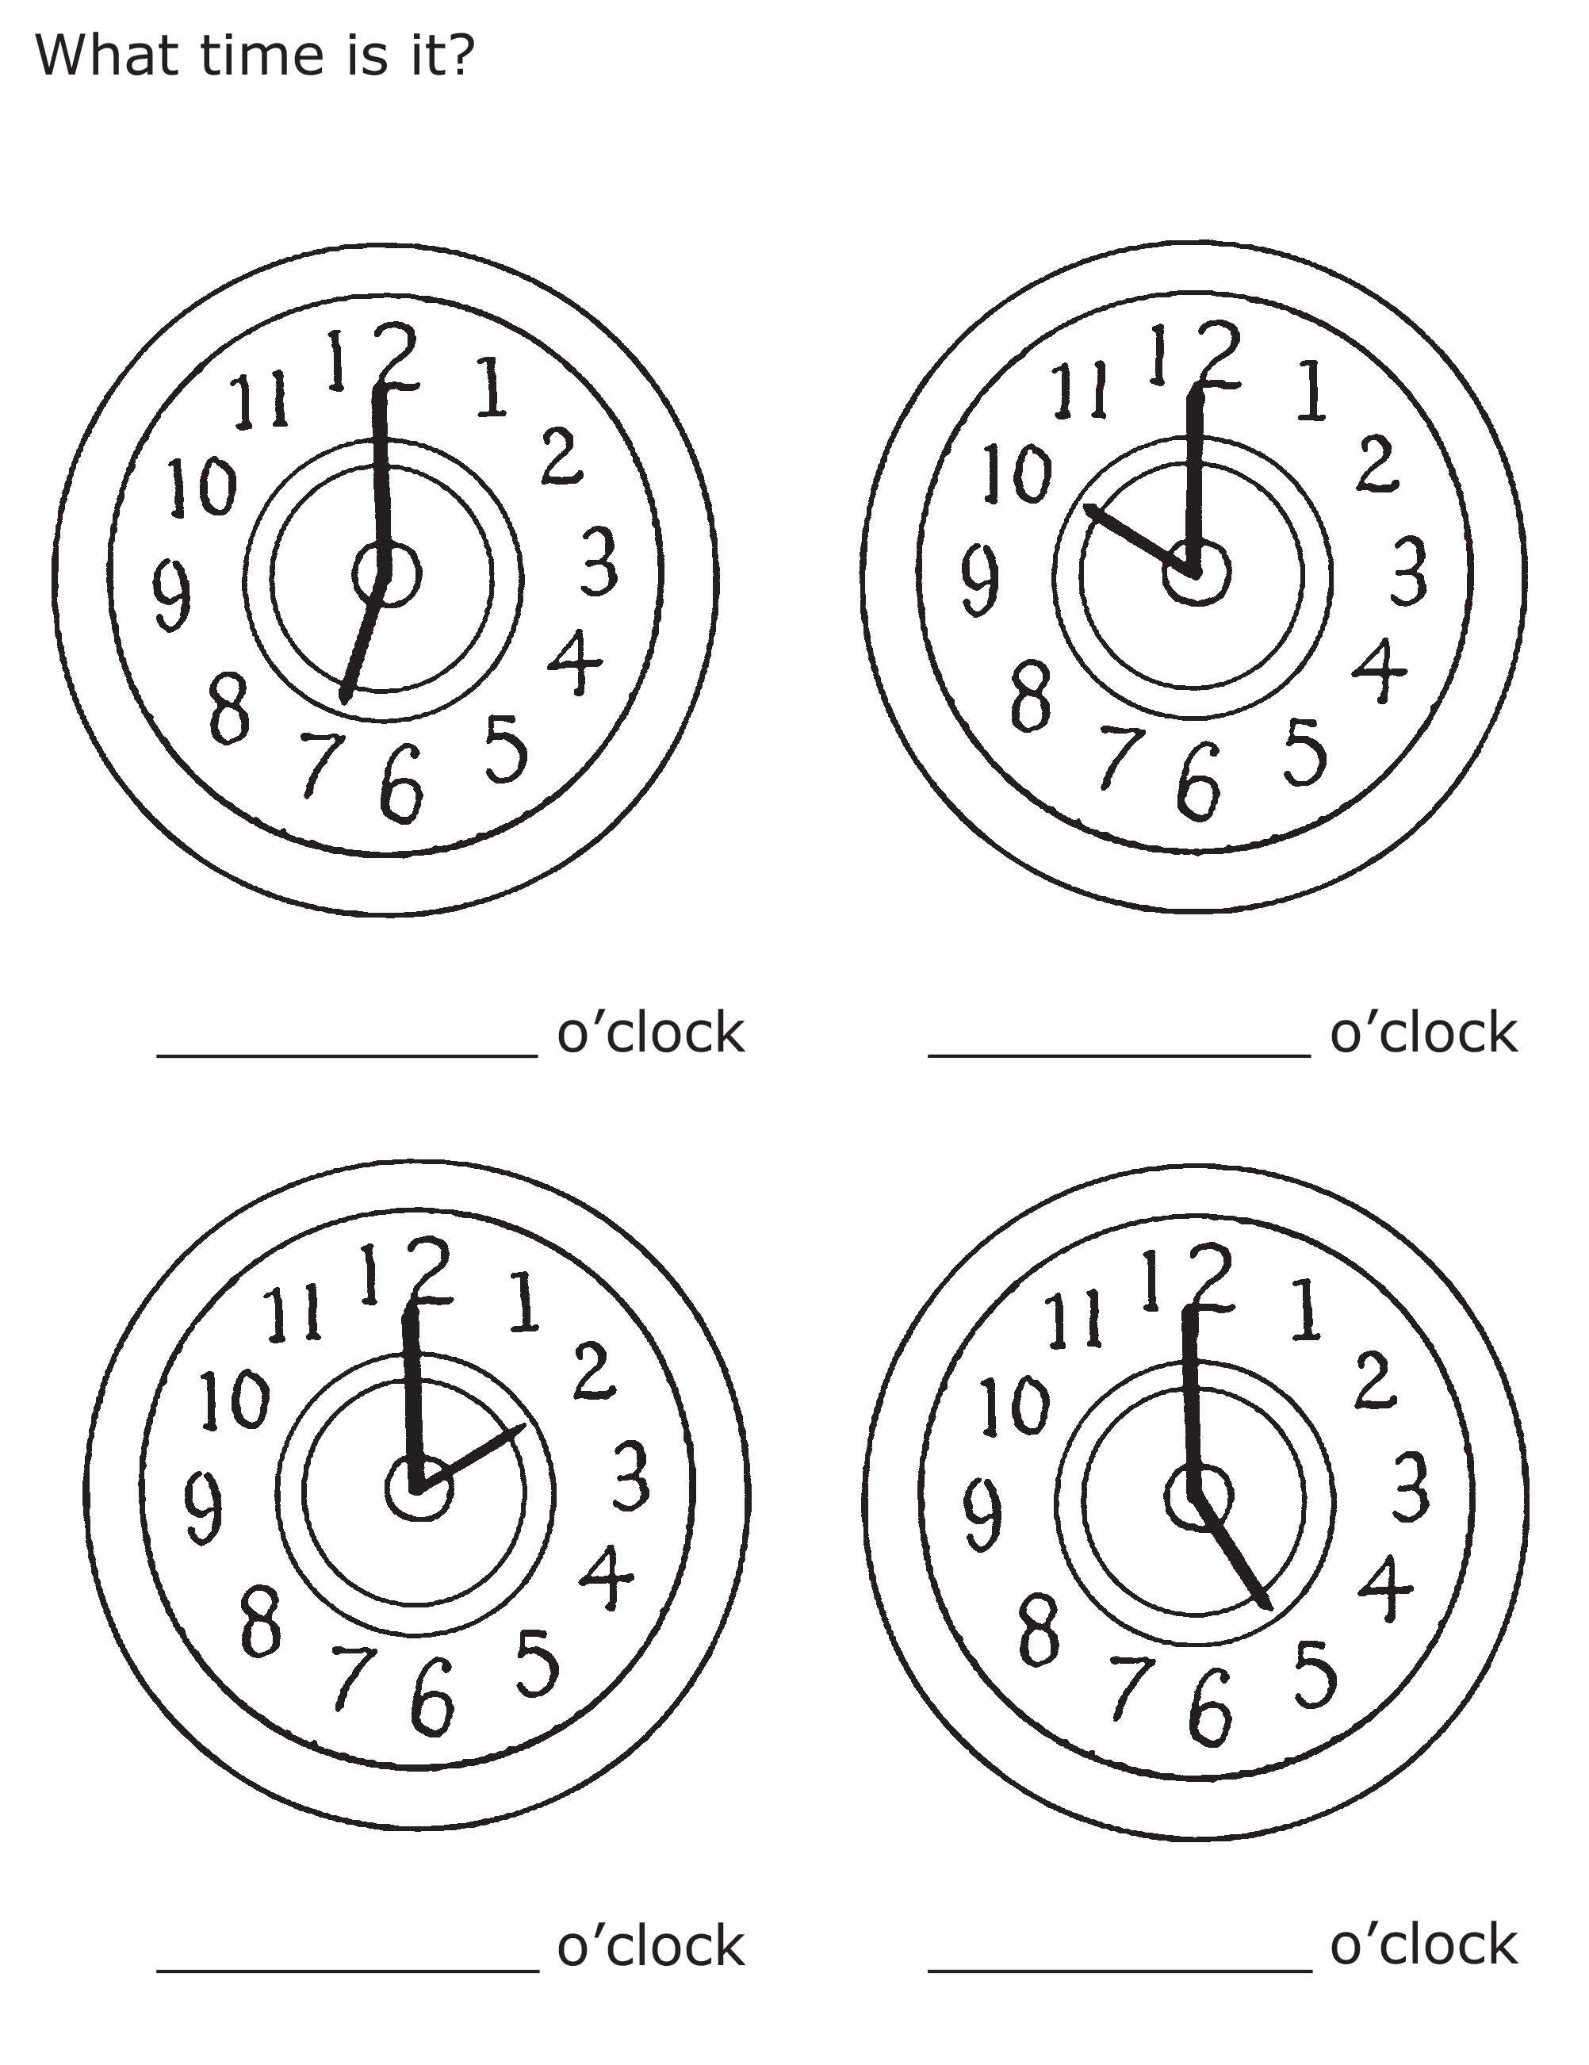

Aim: to practise telling the time.

Trek’s World Travels
Where in the world does Trek learn about time?
Mexico

