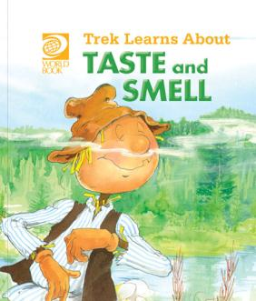
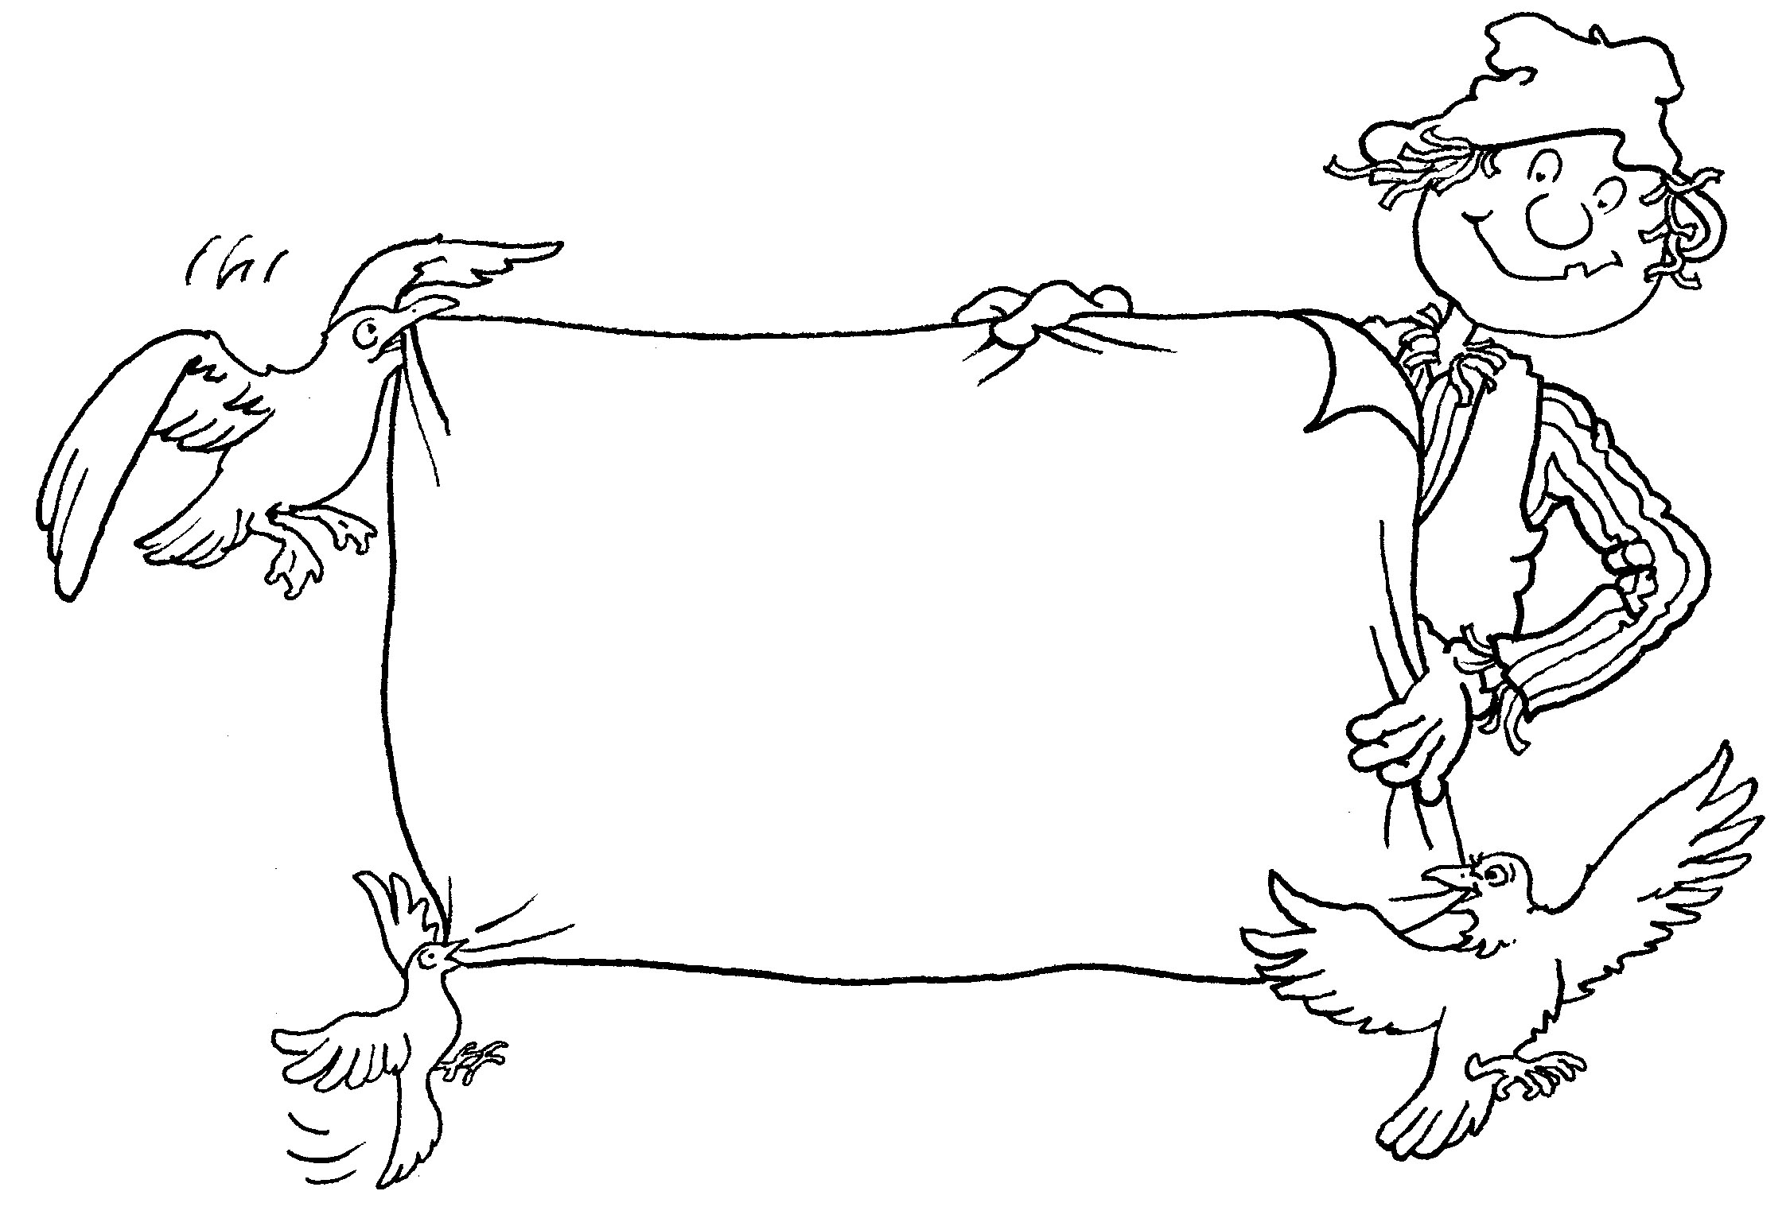
Trek’s Travels –

TASTE and SMELL

Talking about taste
1. What food does Crow like to eat?
_________________________________________________________________
2. What food does Seagull like to eat?
_________________________________________________________________
3. What food does Wagtail like to eat?
_________________________________________________________________
4. Would you like to eat any of those foods?
_________________________________________________________________
5. Why do you think Trek didn’t want to eat them?
_________________________________________________________________6. What food did Trek enjoy?
_________________________________________________________________

Talking about food
1. Have you ever eaten blackberries, like Wagtail?
_________________________________________________________________
2. Did you like the taste?
_________________________________________________________________3. Have you ever eaten honey, like the black bear?
_________________________________________________________________

4. Was it sweet or bitter?
_________________________________________________________________5. Have you ever eaten nuts, like the chipmunk?
_________________________________________________________________6. What do we do to nuts before we can eat them?
_________________________________________________________________7. We can’t eat everything that other animals eat. Can you make a list?
_________________________________________________________________8. What is your favourite food?
_________________________________________________________________

ACTIVITY –
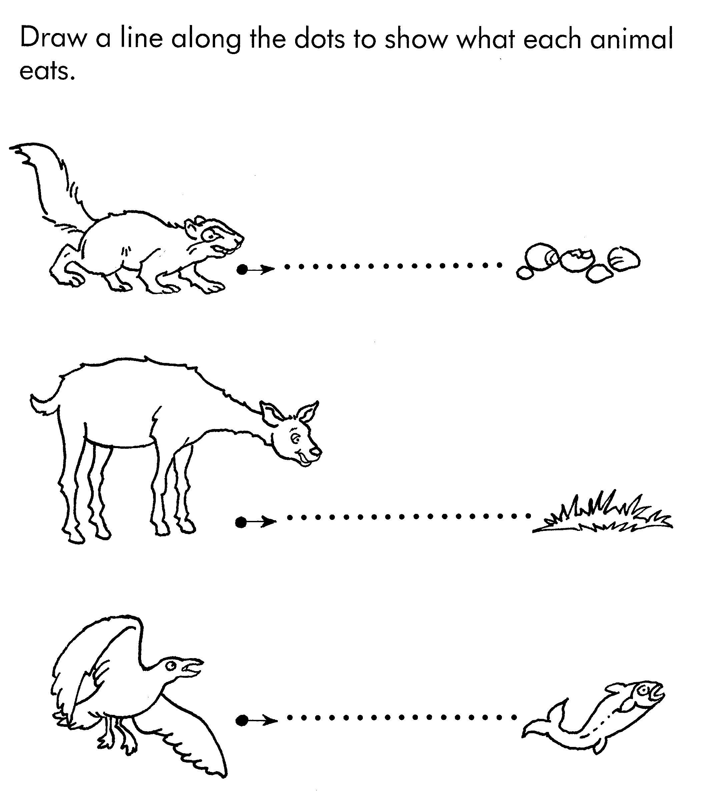

Aim: to practice pencil control.
ACTIVITY –

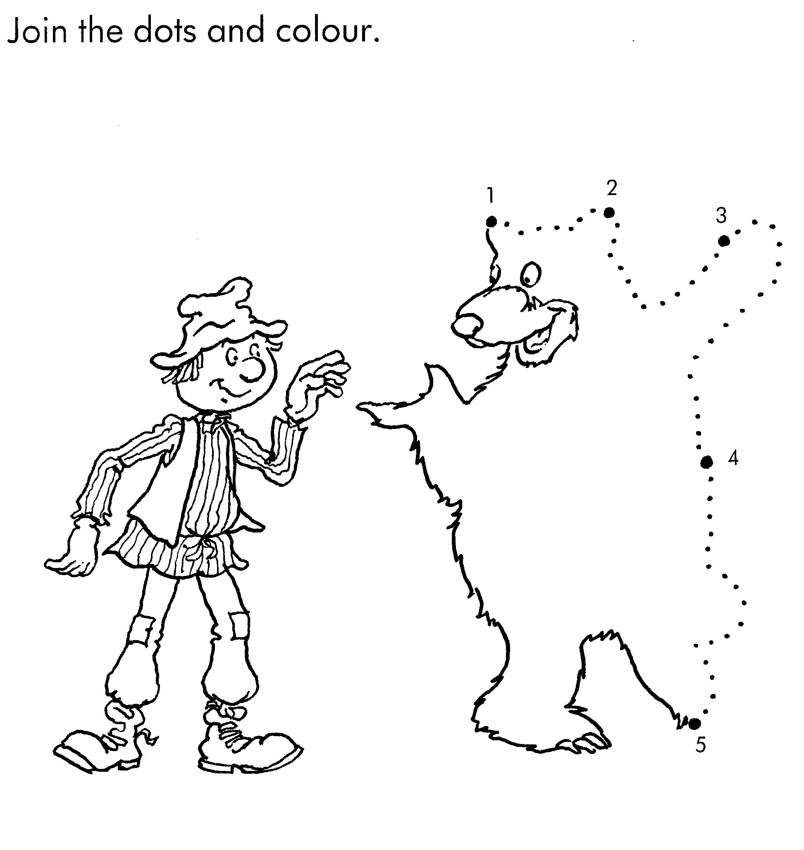

Aim: to practice pencil control and count to five.

Trek’s World Travels
Where in the world does Trek learn about taste and smell?
Canada

